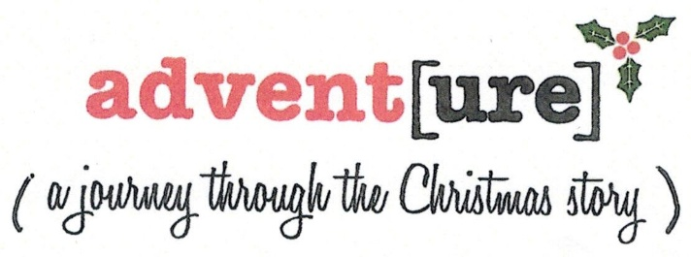

Week 2 - Mary and Joseph go to Bethlehem
Main Theme: Responsibility
Read Luke 2:1-7
We have to live in the world we are born to. Traveling to Bethlehem was a great inconvenience considering Mary is many months pregnant, yet the couple responded to the order to register. When they arrived there was no place to stay, and the time came for the baby to be born.

• Did they go without question because they knew the child would be born in Bethlehem according to prophecy?

• Considering Mary's pregnancy and unwed state, did they welcome the opportunity to leave their hometown?

• Is there a difference between responsibility and obligation?

NOTES:

What things in life are inconvenient? Think about the last unexpected thing you did. How big an inconvenience was it? Did it drastically impact your plans or did it make things better? Many times it’s easy to catch ourselves being inconvenienced by the things we don't want to do or aren't excited to do, but unexpected things that have a favorable result are fun and can even open new doors that produce positive emotions. These are often called surprises. Nothing in Scripture says that Mary or Joseph were frustrated by the timing of this. We have put an assumption on it that she was uncomfortable (a fair and realistic assumption), and they were terribly inconvenienced. Or maybe Mary was glad to get out of town.

In our limited understanding of Biblical times we too often make Mary already past her due date, miserable and exhausted as she travels to Bethlehem. Sure, the three days of travel may have worn her out, but she had recently returned from a first trimester trip to visit Elizabeth. We also tend to tie a nice glittery ribbon around the Christmas story: Mary and Joseph adhere to the decree and travel to Bethlehem. Although there was no room in the inn, they were offered the stable and welcomed by all the adorable animals in the stable. We don't want to think about the fact that Mary's condition by cultural standards called for her execution. Joseph was supporting her (Matthew 2:18-25 tells us how he received the news), choosing to respond in a way which was different than he would have been taught was acceptable. While it makes sense that they probably welcomed this "babymoon' in the back of their minds, in the midst of all the inconveniences had to be Gabriel's words to Mary "Rejoice, favored one! The Lord is with you:'
There are things in life we do out of obligation. We make a promise or agree to do something and are obligated through by word to follow through. Other things in life we do out of responsibility. We're aware of something, we've made a choice at some point in life and are taking care of something or someone, and following through with it is on us. How many things that you are involved in around this time of year feel like an obligation?

Take a moment to think about it. List all the things you feel responsible for. (Note the word feel - not are, are not, should be, etc.) How many of these things are inconvenient? How many of these drain you of energy? How many fill you with joy? Which do you look forward to the most?

A google search of the phrase "causes of stress during holiday season" produced more than 50 million results. Fifty million! Articles and websites providing insight to the causes, coping skills to get through the season, ways to avoid it all together, and more are all at our fingertips because this time of year can be chaotic. Typically its one of two extremes - ridiculously busy or heart-achingly lonely. A stroll around social media is a reminder that people are busy, and that were silently measuring ourselves against what other people are doing or buying, or where they're going.

• How busy are you during the holiday season?

• What things take up your time that are things you actually have to do?

• What things are you pressured to do—expectations or obligations you feel like you can't avoid?

• If money, time, expectation or location weren't factors, what would this season look like for you?
Romans 8:31 says '.. if God is for us who can be against us?"

• When have you felt overwhelmed?

• What gets you through the overwhelmed, unexpected and inconvenient moments?

NOTES:

