February 22, 2026
1st Sunday in Lent

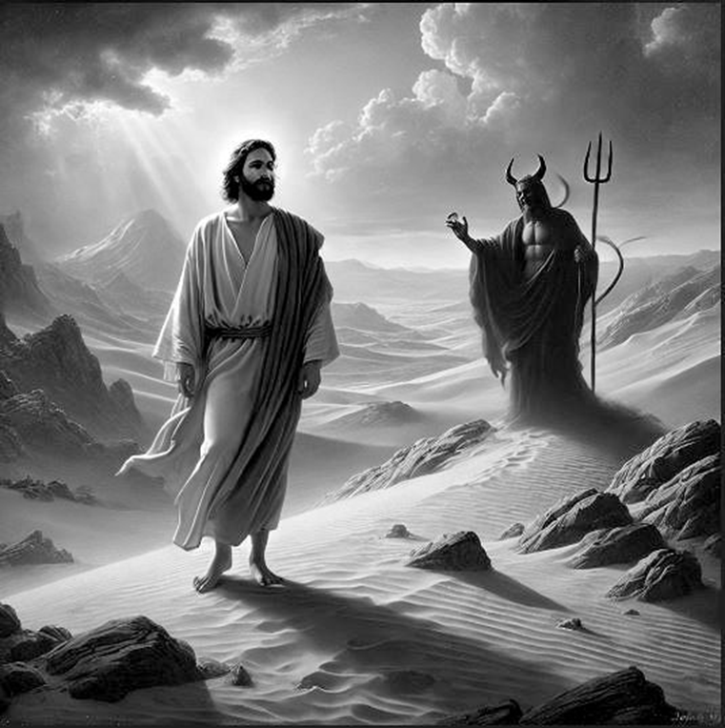

Crescentville United Methodist Church
A Changing Church for Changing Times
Pastor Rev. Lori Reyes
412 Sentner Street
Philadelphia, Pennsylvania 19120
215-745-7115
E-Mail: crescentvilleumc@gmail.com
Web Site: https://www.crescentvilleumc.com/
Facebook: https://www.facebook.com/crescentvilleumc
YouTube Channel:
https://www.youtube.com/@crescentvilleunitedmethodi7688

Crescentville United Methodist Church
1st Sunday in Lent February 22, 2026

The Service of Diminishing Lights on a crown of thorns is used at the beginning of our worship service to put an emphasis on the weeks that rapidly move from Ash Wednesday to Easter Sunday morning. Like the Advent Wreath, the circle of gathering darkness created by the candles and the crown of thorns serves as a constant reminder of the role of human sin in bringing about the crucifixion and the need for Resurrection.

By participating in a weekly rite as a part of the worship experience, individuals can use the silent time available surrounding this service to contemplate their role in the Lenten story. Families, individuals, young and old can be used as participants in this service, as well as acolytes, church officers, and other worship leaders.

May your Lenten season lead you to an empty tomb and a chorus of Hallelujahs.

PLEASE STAND AS WE BEGIN OUR TIME OF WORSHIP – “Where Charity & Love Prevail”
Where charity and love prevail, there God is ever found;
brought here together by Christ’s love, by love are we thus bound.

Forgive we now each other’s faults as we our faults confess;
and let us love each other well in Christian holiness.

No race nor creed can love exclude if honored be God’s name;
our brotherhood embraces all whose Father is the same.

Welcome and Announcements

Please stand

Chorus of Welcome “The Family of God”
I’m so glad I’m a part of the family of God—I’ve been washed in the fountain, cleansed by His blood! Joint heirs with Jesus as we travel this sod; for I’m part of the family, the family of God.

Call to Worship

Leader: During the weeks before Christmas we celebrate the anticipation of the coming
of the Christ child with candles. One by one during Advent, we light the candles of:

ALL: Peace, Hope, Joy, and love.

Leader: All in preparation for the beginning of Christ's life on earth. All this culminates on Christmas
Day, a holy day, when we light the Christ candle itself. It represents the light of Jesus Christ's -

ALL: Shining in the world; Living in our midst; Coming forth to save us;
inviting us to its warmth. That is a joyous season.

Leader: Today we are in another season — the season of Lent. Lent is the season before Easter.
It is in some ways the opposite of Advent. It is a sober season.

ALL: It is the time of preparation for the coming of Christ's Passion Week.

Leader: During Lent, we tune in to the dark days that got darker, and even darker,
ending in Christ's death.

ALL: They were days of Rejection and suffering, Conflict and betrayal, that ended
with the extinguishing of the light of the Christ candle that was lit at Christmas.

Leader: That light would be rekindled and lit again in each of us, but in these coming weeks,
let us tune in to the darkening days of Lent, as we one by one extinguish the candles
set before us, until on Good Friday, the flame on the Christ candle dies.

(extinguish the flame of one purple candle)

Choral Response: “More love to Thee, oh Christ”

More love to Thee, oh Christ, more love to Thee! Hear Thou the prayer I make on bended knee...
This is my earnest plea More love, oh Christ, to Thee More love to Thee, more love to Thee!
More love to Thee, more love to Thee!

Please be seated
Prayer of Confession (seated and bowed)

We admit we are hesitant to walk to Jerusalem and beyond with you, God of Glory. In a world where we worry about tomorrow before enjoying today, we race by your moments of silence, of learning. In that flood of worries, which can overwhelm us, we may miss that assurance that you have not cut us off from your grace. In the deserts of our desires, we may ignore that feast of hope, of joy, of life you offer to us. Forgive us and have mercy on us, Gentle Guardian of our souls. In humility, may we offer our lives to others. In love, may we share your grace with everyone we meet. In hope, may we wait for you all our days, as you come to us in the life and joy of Jesus Christ, our Lord and Savior.

Silent Meditation…………………….Words of Forgiveness

Opening Praise Song “I Surrender All” Reggae Worship

All to Jesus I surrender, all to Him I freely give;
I will ever love and trust Him, in His presence daily live.
I surrender all, I surrender all.
All to Thee, my blessed Savior, I surrender all.
All to Jesus I surrender, Make me Savior, wholly Thine;
Let me feel Thy Holy Spirit, Truly knowing that Thou art mine.
I surrender all, I surrender all.
All to Thee, my blessed Savior, I surrender all.
OOO
All to Jesus I surrender, All to Him I freely give;
I will ever love and trust Him in His presence daily live.
I surrender all, I surrender all.
All to Thee, my blessed Savior, I surrender all.
All to Jesus I surrender, Make me Savior, wholly Thine;
Let me feel Thy Holy Spirit, Truly knowing that Thou art mine.
I surrender all, I surrender all
All to Thee, my blessed Savior,
I surrender all. I surrender all, Oh I surrender all
All to Thee, my blessed Savior, I surrender all.
Oh I surrender all, I Surrender Oooo……………..

Opening Prayer (in unison)
Holy God, by the grace of Jesus Christ, you know the tests and trials we face. Journey with us through this wilderness. Come to us with ministers of healing and visit us with messengers of hope, so that we may return to you in faith, believing the good news of the gospel; through Jesus Christ, our Savior.

Please Be Seated
Youth Message

Joys & Concerns …………….Gathered Prayer

Singing of THE LORD'S PRAYER–
Our Father, which art in heaven, hallowed be Thy name; Thy kingdom come, Thy will be done, on earth as it is in heaven. Give us this day our daily bread; and forgive us our debts as we forgive our debtors. And lead us not into temptation, but deliver us from evil. For Thine is the kingdom,
and the power, and the glory, forever. Amen
Gifts and Offerings
Offertory “Jesus Walked This Lonesome Valley” Please join in singing!
Please stand
The Doxology “Praise God, from Whom All Blessings Flow”
Praise God from whom all blessings flow, Praise Him all creatures here below.
Praise Him above ye heavenly host; praise Father, Son, and Holy Ghost.

The Offertory Prayer

Dismissal of the Youth

Hymn Lord Who Throughout These 40 Days [vs 1-4] #269

Lord, who throughout these forty days for us did fast and pray,
teach us with Thee to mourn our sins and close by Thee to stay.

As Thou with Satan didst contend, and didst the victory win,
O give us strength in Thee to fight, in Thee to Conquer sin.

As Thou didst hunger, bear, and thirst, so teach us gracious Lord,
to die to self, and chiefly live by Thy most holy Word.

And through these days of penitence, and through Thy passion tide,
yea, evermore in life and death, Jesus with us abide.

Please be seated

Scripture Lesson Matthew 4:1-11 The Testing of Jesus

Then Jesus was led up by the Spirit into the wilderness to be tested by the devil. ² He fasted forty days and forty nights, and afterward he was famished. ³ The tempter came and said to him, “If you are the Son of God, command these stones to become loaves of bread.” ⁴ But he answered, “It is written, ‘One does not live by bread alone, but by every word that comes from the mouth of God.’ ” ⁵ Then the devil took him to the holy city and placed him on the pinnacle of the temple, ⁶ saying to him, “If you are the Son of God, throw yourself down, for it is written, ‘He will command his angels concerning you,’ and ‘On their hands they will bear you up, so that you will not dash your foot against a stone.’ ” ⁷ Jesus said to him, “Again it is written, ‘Do not put the Lord your God to the test.’ ” ⁸ Again, the devil took him to a very high mountain and showed him all the kingdoms of the world and their glory, ⁹ and he said to him, “All these I will give you, if you will fall down and worship me.” ¹⁰ Then Jesus said to him, “Away with you, Satan! for it is written, ‘Worship the Lord your God, and serve only him.’ ” ¹¹ Then the devil left him, and suddenly angels came and waited on him.

Sermon "When The Wilderness Talks Back”

Please stand
*Affirmation of Faith The Apostles’ Creed

I believe in God the Father Almighty, maker of heaven and earth;
And in Jesus Christ His only Son our Lord:
who was conceived by the Holy Spirit, born of the Virgin Mary,
suffered under Pontius Pilate, was crucified, dead, and buried;
the third day He rose from the dead; He ascended into heaven,
and sitteth at the right hand of God the Father Almighty;
from thence He shall come to judge the quick and the dead;

I believe in the Holy Spirit, the holy catholic church,
the communion of saints, the forgiveness of sins,
the resurrection of the body, and the life everlasting. Amen.

Closing Hymn “Seek Ye First” # 405

Seek ye first the kingdom of God and His righteousness;
And all these things shall be added unto you. Hallelu, Hallelujah!

Man shall not live by bread alone, But by every word
That proceeds out from the mouth of God. Hallelu, Hallelujah!

Ask, and it shall be given unto you; Seek, and you shall find.
Knock, and the door shall be opened unto you. Hallelu, Hallelujah!

Benediction

Choral Benediction “Take Time To Be Holy” [Vs 1] # 295
Take time to be holy, speak oft with thy Lord; Abide in Him always and feed on His Word.
Make friends of God’s children, help those who are weak, Forgetting in nothing His blessing to seek.


Lectionary Scripture Readings
Reading the bible solidifies your faith and builds your doctrine. We become firm in our faith when we know what we actually believe and why we believe it.
March 1, 2026 - Second Sunday in Lent
John 3:1-17 - Genesis 12:1-4a - Psalm 121 - Romans 4:1-5, 13-17

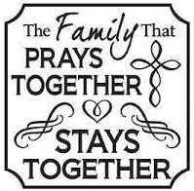
Joys & Concerns: Keep those prayers going and thank God for His answers! To add a prayer request or share a joy, please call or text Sue Creevey 267-847-6029.
People who dedicate part of their time to others have been found to have higher self-esteem and overall well being. The benefits of taking care of someone also depend on your consistency. So, the more regularly you pray for someone, the more confidence you’ll gain. Pray for others and improve your self-esteem.
Prayer Requests from February 15th
JOY - Praise God we are worshiping in person!
For Ilie who lives in Romania and he is seriously sick.
JOY - Dendes finally had heat in her home, but then the pipes burst. She is happy to now be able to go home.
Cass C thanks God for His healing power as she is feeling much better.
Continuing prayers for Cass’s daughter Amber Sarkar, she is currently in rehab and needs to find a place to live by February 18th, as Cass is not able to care for her at home.
Rhonda's Mom, June Trentham is home now, but needs to return to the hospital for father testing.
Prayers for Lupe Carson, Rhonda's neighbor who in now in hospice care.
Cocoa's dog Diesel did well with his dental surgery
Prayers for Cocoa's friend, Tommie as her Aunt PeeWee is now in hospice care.
Prayers for Salem, Cass's cat who has asthma and won't take his medicine.
Traveling mercies for Kim Farrer as she returns from a business trip.
Prayers for Carol Kennedy who is being treated for breast cancer.
Continued prayers for Kerri, Dan, Lee, & John.

Continuing Prayers for:
Martha & Wondor Korto Sheryl Duke David & Esther Clinton Tracey & Bill Lewis
Pastor Lori Amber Sarkar Lori Rovevelli Crescentville UMC
Prayers for those living with constant pain and other ailments.
For those who are sick, and those that grieve. For those who live in war zones and poverty.

For families, especially:
Zilpha and James Browne, The Stefanescu, Mc Manus, Salvadore, and Didirea Families, Jean Bernard and family, The Spotts Family, Bresnan Family

For an end to violence, for peace and stability
Philadelphia, especially our community - Sierra Leone, Africa
Haiti - Israel and Hamas - Ukraine and Russia

Please praise and pray for our youth – they are the future of our church!

UPCOMING WORSHIP & EVENTS

Ad Council – Date TBD

Feb 18th thru April 2nd - The season of Lent

March 1st – 2nd Sunday of Lent - Holy Communion

Wednesdays March 4,11,18,25. Lent Bible Study on Zoom - See our Website for more informaiton

Saturday March 7th – Tools For Ministry

South-East Region Tools for Ministry

The South-East Region Tools for Ministry is a transformative training event for both laity and clergy. Join us in this wonderful opportunity– workshops designed to spark fresh ideas, expand ministry beyond church walls, and prepare you for impactful leadership.
Whether you’re looking to deepen your faith or explore new ways to serve, come and be inspired, equipped, and empowered for God’s work in the world.
Location: Palmer Theological Seminary at Eastern University, 1300 Eagle Rd Wayne, PA 19087, McInnis Building
Date: March 7th from 8:30am – 12:30pm
Registration fee: $15 – online registration only.
Link for registration our website. https://www.crescentvilleumc.com/
Coffee and Breakfast Snack available
Registration will be closed on Wed. March 4th at midnight.
No on-site registration will be taken.
Link to course descriptions available on our website. https://www.crescentvilleumc.com/

Schedule:
Registration 8:30 AM-9:00 AM
Welcome & Devotions 9:00 AM-9:15 AM
Session 1 9:15 AM-10:45 AM
Break 10:45 AM-11:00 AM
Session 2 11:00 AM-12:30 PM

Monday, March 9th – Women’s Fellowship - Noon

March 29th – Palm Sunday 10:30 Worship - Bowling party in the afternoon.


April 2nd - Maundy Thursday 7:00 PM Worship – Holy Communion & stripping of altar.

April 3rd – Good Friday 7:00 PM Tenebrae service

April 5th – Easter Sunday – NO HOLY COMMUNION – Holy Communion will be on April 19th

April 12th – Laity Sunday

April 19th – Youth Sunday – topic Earth Day - Holy Communion

April 26th – After worship Women’s Fellowship Fashion show “Apron Strings for Spring”

An Invitation for Lent
MEETING GOD IN THE WILDERNESS
A 4-Week Lenten Journey……..
Lent is a season of slowing down, paying attention, and listening for God in honest places.
In Scripture, the wilderness is where God meets people, not after everything is figured out, but right in the middle of uncertainty, struggle, and waiting.
This Lent, we invite you to join a 4-week Zoom study called “Meeting God in the Wilderness”.
This study is not about having the right answers. It is about showing up, listening deeply, and sharing honestly.

What This Study Is
A weekly small-group conversation grounded in Scripture
A space for reflection, listening, and shared wisdom
A reminder that God is present even in difficult seasons
Each week focuses on a different aspect of the wilderness journey:
Entering the Wilderness
Learning to Depend on God
Being Formed in the Wilderness
Coming Out of the Wilderness Changed

What This Study Is Not
Not a lecture
Not homework-heavy
Not about being an “expert” in the Bible
You are welcome just as you are!

How It Works
We will meet once a week on Zoom (50 minutes)
Each week, you’ll receive a short Scripture reading and reflection questions ahead of time
You’re encouraged (but not required) to read and reflect before we meet
Our Zoom time will focus on conversation and shared reflection, often in small breakout groups (depending on how many participants). You may share as much or as little as you’re comfortable with.

What You’ll Need
A Bible (any translation)
A quiet space for Zoom, when possible
An open heart and a willingness to listen…That’s it.

Here are the Wednesdays we will meet:
February 25th, March 4th, March 11th, and March 18th at 7:00pm

Topic: Lenten Group Study on Zoom
Time: Feb 25, Mar 04,11,18, 2026
07:00 PM Eastern Time (US and Canada)

Join Lenten group study on Zoom
https://us02web.zoom.us/j/82405298145?pwd=JQqKLROTDQ6xAxpIzPiD7sKRBk7YbI.1

Meeting ID: 824 0529 8145 Passcode: 456377

Link for this study is also on our website

