APRIL 02, 2026
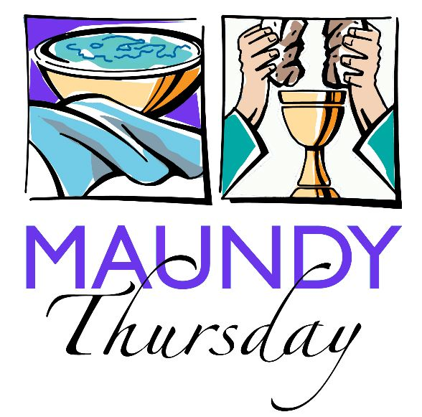

Crescentville United Methodist Church
A Changing Church for Changing Times
Pastor Rev. Lori Reyes
400 Sentner Street
Philadelphia, Pennsylvania 19120
215-745-7115
E-Mail: crescentvilleumc@gmail.com
Web Site: https://www.crescentvilleumc.com/
Facebook: https://www.facebook.com/crescentvilleumc
YouTube Channel:
https://www.youtube.com/@crescentvilleunitedmethodi7688

Crescentville United Methodist Church

Maundy Thursday Holy Communion April 02, 2026

The Service of Diminishing Lights on a crown of thorns is used at the beginning of our worship service to put an emphasis on the weeks that rapidly move from Ash Wednesday to Easter Sunday morning. Like the Advent Wreath, the circle of gathering darkness created by the candles and the crown of thorns serves as a constant reminder of the role of human sin in bringing about the crucifixion and the need for Resurrection.

By participating in a weekly rite as a part of the worship experience, individuals can use the silent time available surrounding this service to contemplate their role in the Lenten story. Families, individuals, young and old can be used as participants in this service, as well as acolytes, church officers, and other worship leaders.

May your Lenten season lead you to an empty tomb and a chorus of Hallelujahs.

Greeting: The Lord be with you! And also with you!

Welcome
The term “Maundy” comes from the Latin “mandatum;” it is from a verb that means “to give” or “to order” — command. After Jesus and the disciples finished the Last Supper and walked toward Gethsemane, Jesus taught them a new commandment — “I give you a new commandment, that you love one another. Just as I have loved you, you also should love one another” (John 13:34).
On Maundy it is customary to “strip the altar,” which symbolizes the abandonment of Jesus by his disciples and the stripping of Jesus by the soldiers before his crucifixion. It represents the humiliation of Jesus and the consequences of sin as a preparation for the celebration of new life.

Please stand
Call to worship

Leader: In this season of Lent, we remember the journey of Jesus toward the cross.

People: We gather in the shadow of the cross, seeking the light of Christ.

Leader: Though fear, betrayal, and darkness surrounded him,

People: The love of Christ did not fail.

Leader: Even when the world’s light seemed to grow dim,

People: God’s mercy and faithfulness remained.

Leader: Come, let us worship the One who walks with us through every darkness.

People: With grateful and humble hearts, we worship the Lord.

(extinguish the last small candle.)

Choral Response: “More love to Thee, Oh Christ” (Vs 1) # 453

More love to Thee, oh Christ, more love to Thee! Hear Thou the prayer I make on bended knee... This is my earnest plea More love, oh Christ, to Thee More love to Thee, more love to Thee! More love to Thee, more love to Thee!

Please be seated
Prayer of Confession (seated and bowed)
Merciful God, on this holy night we remember the love of Christ shown at the table and on the cross. Yet we confess that we have not loved as he loved. Too often we choose pride instead of humility, distance instead of service, and silence instead of compassion. Like the crown of thorns placed upon your head, our sin has wounded your heart. Forgive us, Lord. Cleanse us by your grace, renew our hearts, and teach us to love and serve one another as Christ has loved us. In Jesus’ name we pray. Amen.

Silent Meditation…………………….Words of Forgiveness

Opening Prayer (Unison)
Gracious God, out of your love and mercy you breathed into dust the breath of life, creating us to serve you and our neighbors. Call forth our prayers and acts of kindness and strengthen us to face our mortality with confidence in the mercy of your Son, Jesus Christ, our Savior and Lord, who lives and reigns with you and the Holy Spirit, one God, now and forever. Amen.

Please stand
HYMN “Jesu, Jesu” [VS 1,3,5] # 432

Refrain: Jesu, Jesu, fill us with your love,
show us how to serve the neighbors we have from You.

Kneels at the feet of his friends, silently washes their feet,
Master who acts as a slave to them. Refrain

These are the ones we should serve, these are the ones we should love;
all these are neighbors to us and you. Refrain

Kneel at the feet of our friends, silently washing their feet,
this is the way we should live with you. Refrain

Please be seated
Receiving God’s Offerings and Gifts

Offertory “The Servant Song” Please join in singing!
Please stand

The Doxology “Praise God, from Whom All Blessings Flow” # 95
Praise God, from whom all blessings flow; praise God, all creatures here below;
praise God above, ye heavenly host; praise Father, Son, and Holy Ghost. Amen.
Offertory Prayer

Please be seated
Scripture Reading John 13:1-17 [RSV]
Jesus Washes the Disciples’ Feet
¹³ Now before the feast of the Passover, when Jesus knew that his hour had come to depart out of this world to the Father, having loved his own who were in the world, he loved them to the end. ² And during supper, when the devil had already put it into the heart of Judas Iscariot, Simon’s son, to betray him, ³ Jesus, knowing that the Father had given all things into his hands, and that he had come from God and was going to God, ⁴ rose from supper, laid aside his garments, and girded himself with a towel. ⁵ Then he poured water into a basin, and began to wash the disciples’ feet, and to wipe them with the towel with which he was girded. ⁶ He came to Simon Peter; and Peter said to him, “Lord, do you wash my feet?” ⁷ Jesus answered him, “What I am doing you do not know now, but afterward you will understand.” ⁸ Peter said to him, “You shall never wash my feet.” Jesus answered him, “If I do not wash you, you have no part in me.” ⁹ Simon Peter said to him, “Lord, not my feet only but also my hands and my head!” ¹⁰ Jesus said to him, “He who has bathed does not need to wash, except for his feet, but he is clean all over; and you are clean, but not every one of you.” ¹¹ For he knew who was to betray him; that was why he said, “You are not all clean.”
¹² When he had washed their feet, and taken his garments, and resumed his place, he said to them, “Do you know what I have done to you? ¹³ You call me Teacher and Lord; and you are right, for so I am. ¹⁴ If I then, your Lord and Teacher, have washed your feet, you also ought to wash one another’s feet. ¹⁵ For I have given you an example, that you also should do as I have done to you. ¹⁶ Truly, truly, I say to you, a servant is not greater than his master; nor is he who is sent greater than he who sent him. ¹⁷ If you know these things, blessed are you if you do them.

Sermon: "Love That Kneels Down"

Interlude: “Be Present at our Table Lord”
The Sacrament of Holy Communion

INVITATION (Pastor)
Christ our Lord invites to his table all who love him,
who earnestly repent of their sin and seek to live in peace with one another.
Therefore, let us confess our sin before God and one another.

CONFESSION AND PARDON (Congregation)
Merciful God, we confess that we have not loved you with our whole heart.
We have failed to be an obedient church. We have not done your will,
we have broken your law, we have rebelled against your love,
we have not loved our neighbors, and we have not heard the cry of the needy.
Forgive us, we pray. Free us for joyful obedience, through Jesus Christ our Lord. Amen.

Hear the good news: Christ died for us while we were yet sinners;
that proves God's love toward us. In the name of Jesus Christ, you are forgiven!
Congregation: In the name of Jesus Christ, you are forgiven!

All: Glory to God. Amen.
The Lord be with you………………………...And also with you.
Lift up your hearts……………………..We lift them up to the Lord.
Let us give thanks to the Lord our God……...It is right to give God thanks and praise.
... And so, with your people on earth and all the company of heaven, we praise your name and join their unending hymn:

HOLY, HOLY, HOLY LORD, GOD OF POWER AND MIGHT,
HEAVEN AND EARTH ARE FULL OF YOUR GLORY,
HOSANNA IN THE HIGHEST. BLESSED IS HE WHO COMES
IN THE NAME OF THE LORD. HOSANNA IN THE HIGHEST.

…And so, in remembrance of these your mighty acts in Jesus Christ, we offer ourselves this day in praise and thanksgiving as a holy and living sacrifice, in union with Christ's offering for us, as we proclaim the joy-filled mystery of faith: CHRIST HAS DIED; CHRIST IS RISEN, CHRIST WILL COME AGAIN.

…Through your Son Jesus Christ, with the Holy Spirit in your holy Church, all honor and glory is yours, Almighty Father, now and forever. AMEN.

BREAKING THE BREAD………………………………….GIVING THE BREAD AND CUP
Communion Hymn: “Lord, Who At Thy First Eucharist Did Pray”
“Let Us Break Bread Together”

PRAYER AFTER COMMUNION
Gracious God, we thank you for this holy meal and the grace we have received at your table. Strengthen us to love and serve one another as Christ has loved us. As we leave this table tonight, help us walk with Jesus in humility and faith. Amen.

Please stand
HYMN “What Wondrous Love Is This” [VS 1-2] # 292

What wondrous love is this, O my soul, O my soul,
what wondrous love is this, O my soul!
What wondrous love is this that caused the Lord of bliss
to bear the dreadful curse for my soul, for my soul,
to bear the dreadful curse for my soul.

What wondrous love is this, O my soul, O my soul,
what wondrous love is this, O my soul!
What wondrous love is this, that caused the Lord of life
to lay aside his crown for my soul, for my soul,
to lay aside his crown for my soul.

Please be seated
STRIPPING THE ALTAR

Reader One: After the Last Supper, less than 24 hours remained in our Lord’s earthly life.
Events moved rapidly: betrayal by Judas, arrest, mock trial, painful beating, the trudge to Golgotha and execution. As His life was stripped from Him, so we strip our altar of the signs of comfort and life to remember Jesus’ suffering and death.

Reader Two: If you have been asked to carry an item, please remove it and take it to the back of the church and place it on the table. Be seated in the back pews.
As we strip the altar we will listen to Isaiah 53.
Please wait until all lights have been dimmed, and the screen benediction is completed, then SILENTLY exit the church building.

Screen Benediction
As you are ready, please leave in silence

THANK YOU FOR JOINING US FOR WORSHIP.
Please join us again tomorrow evening at 7:00 PM
as we worship with a Good Friday Tenebrae service

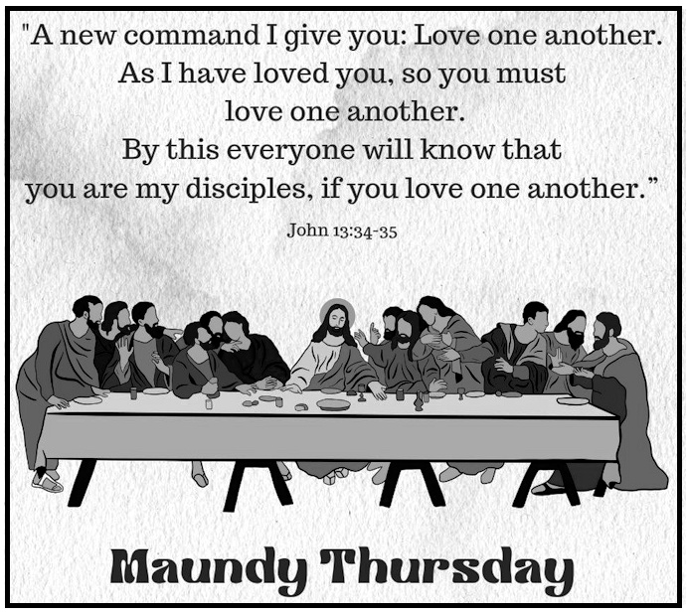

Please join us for
UPCOMING WORSHIP & EVENTS

Feb 18th thru April 2nd - The season of Lent

April 2nd - Maundy Thursday 7:00 PM Worship
Holy Communion & stripping of altar.
No video recording for this service – please join us in church!

April 3rd – Good Friday 7:00 PM Tenebrae service
No video recording for this service – please join us in church!

April 5th – Easter Sunday NO HOLY COMMUNION
Holy Communion will be on April 19th
Morning refreshments will be served from 9:30 AM – 10:15 AM
Coffee Hour after worship.

April 12th – Laity Sunday

April 19th – Youth Sunday – topic Earth Day
Holy Communion

April 26th – After worship Women’s Fellowship
Fashion show “Apron Strings for Spring

