March 26, 2023
5th Sunday in Lent
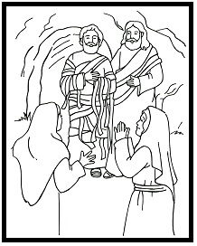

Crescentville United Methodist Church
A Changing Church for Changing Times
Rev. Randy M. Brubaker, Pastor
412 Sentner Street
Philadelphia, Pennsylvania 19120
215-745-7115
E-Mail: crescentvilleumc@gmail.com
Web Site: https://www.crescentvilleumc.com/
Facebook: https://www.facebook.com/crescentvilleumc
YouTube Channel:
https://www.youtube.com/@crescentvilleunitedmethodi7688

Of all of this well known story of Jesus raising His friend Lazarus from the grave, Thomas’ words to his fellow disciples, “Let us go too so that we may die with Jesus” seem strangely out of place. Or do they? Following Jesus is all about life and death. Sin and grace. And our trusting God in ALL of it…

Crescentville & Frankford Memorial United Methodist Churches

Fifth Sunday in Lent March 26, 2023

Welcome

Chorus of Welcome “The Family of God”
I’m so glad I’m a part of the family of God—I’ve been washed in the fountain, cleansed by His blood!
Joint heirs with Jesus as we travel this sod; for I’m part of the family, the family of God.

*Call to Worship Psalm 130

I wait for the Lord, my soul waits, and in his word I hope; my soul waits for the Lord
more than those who watch for the morning, more than those who watch for the morning.
O Israel, hope in the Lord! For with the Lord there is steadfast love,
and with him is great power to redeem. It is he who will redeem Israel from all its iniquities.

*Hymn of Confession “Out of the Depths I Cry to You” [VS. 1-2] [TUNE: MIT FREUDEN ZART] # 515

Out of the depths I cry to You; O Lord, now hear me calling. Incline Your ear to my distress
in spite of my rebelling. Do not regard my sinful deeds. Send me the grace my spirit needs;
without it I am nothing.

All things You send are full of grace; You crown our lives with favor. All our good works are done in vain
without our Lord and Savior. We praise the God who gives us faith and saves us from the grip of death;
our lives are in God’s keeping

Prayer of Confession (seated and bowed) Psalm 130

Out of the depths I cry to you, O Lord. Lord, hear my voice!
Let your ears be attentive to the voice of my supplications!
If you, O Lord, should mark iniquities, Lord, who could stand?
But there is forgiveness with you, so that you may be revered. Amen.

Silent Prayer and Meditation………………..Words of Forgiveness

Hymn of Grace “Out of the Depths I Cry to You” [VS. 3-4] [TUNE: MIT FREUDEN ZART] # 515

It is in God that we shall hope, and not in our own merit; we rest our fears in God’s good Word
and trust the Holy Spirit, whose promise keeps us strong and sure; we trust the holy signature
inscribed upon our temples.

My soul is waiting for the Lord as one who longs for morning; no watcher waits with greater hope
than I for Christ’s returning. I hope as Israel in the Lord, who sends redemption through the Word.
Praise God for endless mercy.

Children’s Message

Joys & Concerns………………….……..Gathered Prayer…………………………The Lord’s Prayer

Our Father, who art in heaven, hallowed be Thy name; Thy kingdom come, Thy will be done,
on earth as it is in heaven. Give us this day our daily bread; and forgive us our trespasses and debts as we forgive our debtors and those who trespass against us. And lead us not into temptation,
but deliver us from evil. For Thine is the kingdom, and the power, and the glory, forever. Amen.

Gifts and Offerings

Offertory “My Name Is Lazarus”

Doxology “Praise God, From Whom All Blessings Flow” [TUNE: HAMBURG]

Praise God, from whom all blessings flow; praise Him, all creatures here below;
praise Him above, ye heavenly host; praise Father, Son, and Holy Ghost. Amen.

The Offertory Prayer

*Hymn “Take Up Thy Cross” # 415

"Take up thy cross," the Savior said, "if thou wouldst my disciple be;
deny thyself, the world forsake, and humbly follow after me."

Take up thy cross, let not its weight fill thy weak spirit with alarm;
his strength shall bear thy spirit up, and brace thy heart and nerve thine arm.

Take up thy cross, nor heed the shame, nor let thy foolish pride rebel;
thy Lord for thee the cross endured, to save thy soul from death and hell.

Take up thy cross and follow Christ, nor think till death to lay it down;
for only those who bear the cross may hope to wear the glorious crown.

Gospel Lesson St. John 11:1-45

A certain man, Lazarus, was ill. He was from Bethany, the village of Mary and her sister Martha.
(² This was the Mary who anointed the Lord with fragrant oil and wiped his feet with her hair. Her brother
Lazarus was ill.) ³ So the sisters sent word to Jesus, saying, “Lord, the one whom you love is ill.”
⁴ When he heard this, Jesus said, “This illness isn’t fatal. It’s for the glory of God so that God’s Son can be
glorified through it.” ⁵ Jesus loved Martha, her sister, and Lazarus. ⁶ When he heard that Lazarus was ill,
he stayed where he was. After two days, ⁷ he said to his disciples, “Let’s return to Judea again.”
⁸ The disciples replied, “Rabbi, the Jewish opposition wants to stone you, but you want to go back?”
⁹ Jesus answered, “Aren’t there twelve hours in the day? Whoever walks in the day doesn’t stumble
because they see the light of the world. ¹⁰ But whoever walks in the night does stumble because the light
isn’t in them.” ¹¹ He continued, “Our friend Lazarus is sleeping, but I am going in order to wake him up.”
¹² The disciples said, “Lord, if he’s sleeping, he will get well.” ¹³ They thought Jesus meant that Lazarus
was in a deep sleep, but Jesus had spoken about Lazarus’ death. ¹⁴ Jesus told them plainly,
“Lazarus has died. ¹⁵ For your sakes, I’m glad I wasn’t there so that you can believe. Let’s go to him.”
¹⁶ Then Thomas (the one called Didymus) said to the other disciples, “Let us go too so that we may die
with Jesus.”
¹⁷ When Jesus arrived, he found that Lazarus had already been in the tomb for four days. ¹⁸ Bethany was
a little less than two miles from Jerusalem. ¹⁹ Many Jews had come to comfort Martha and Mary after
their brother’s death. ²⁰ When Martha heard that Jesus was coming, she went to meet him, while Mary
remained in the house. ²¹ Martha said to Jesus, “Lord, if you had been here, my brother wouldn’t have
died. ²² Even now I know that whatever you ask God, God will give you.” ²³ Jesus told her, “Your brother
will rise again.” ²⁴ Martha replied, “I know that he will rise in the resurrection on the last day.”
²⁵ Jesus said to her, “I am the resurrection and the life. Whoever believes in me will live, even though
they die. ²⁶ Everyone who lives and believes in me will never die. Do you believe this?” ²⁷ She replied,
“Yes, Lord, I believe that you are the Christ, God’s Son, the one who is coming into the world.”
²⁸ After she said this, she went and spoke privately to her sister Mary, “The teacher is here and he’s calling
for you.” ²⁹ When Mary heard this, she got up quickly and went to Jesus. ³⁰ He hadn’t entered the village
but was still in the place where Martha had met him. ³¹ When the Jews who were comforting Mary in the
house saw her get up quickly and leave, they followed her. They assumed she was going to mourn at
the tomb. ³² When Mary arrived where Jesus was and saw him, she fell at his feet and said, “Lord, if you
had been here, my brother wouldn’t have died.” ³³ When Jesus saw her crying and the Jews who had
come with her crying also, he was deeply disturbed and troubled. ³⁴ He asked, “Where have you laid
him?” They replied, “Lord, come and see.” ³⁵ Jesus began to cry. ³⁶ The Jews said, “See how much
he loved him!” ³⁷ But some of them said, “He healed the eyes of the man born blind.
Couldn’t he have kept Lazarus from dying?”
³⁸ Jesus was deeply disturbed again when he came to the tomb. It was a cave, and a stone covered
the entrance. ³⁹ Jesus said, “Remove the stone.” Martha, the sister of the dead man, said, “Lord,
the smell will be awful! He’s been dead four days.” ⁴⁰ Jesus replied, “Didn’t I tell you that if you believe,
you will see God’s glory?” ⁴¹ So they removed the stone. Jesus looked up and said, “Father, thank you
for hearing me. ⁴² I know you always hear me. I say this for the benefit of the crowd standing here so that
they will believe that you sent me.” ⁴³ Having said this, Jesus shouted with a loud voice, “Lazarus,
come out!” ⁴⁴ The dead man came out, his feet bound and his hands tied, and his face covered with
a cloth. Jesus said to them, “Untie him and let him go.” ⁴⁵ Therefore, many of the Jews who came
with Mary and saw what Jesus did believed in him.

Sermon “Let Us Go Too…”

Affirmation of Faith The Apostles’ Creed

I believe in God the Father Almighty, maker of heaven and earth;
And in Jesus Christ His only Son our Lord:
who was conceived by the Holy Spirit, born of the Virgin Mary,
suffered under Pontius Pilate, was crucified, dead, and buried;
the third day He rose from the dead; He ascended into heaven,
and sitteth at the right hand of God the Father Almighty;
from thence He shall come to judge the quick and the dead;

I believe in the Holy Spirit, the holy catholic church,
the communion of saints, the forgiveness of sins,
the resurrection of the body, and the life everlasting. Amen.

*Hymn “Where He Leads Me” [VS. 1-3] # 338

I can hear my Savior calling, I can hear my Savior calling,
I can hear my Savior calling, "Take thy cross and follow, follow me."

Refrain: Where he leads me I will follow, where he leads me I will follow,
where he leads me I will follow; I'll go with him, with him all the way.

I'll go with him through the garden, I'll go with him through the garden,
I'll go with him through the garden, I'll go with him, with him all the way. Refrain

I'll go with him through the judgment, I'll go with him through the judgment,
I'll go with him through the judgment, I'll go with him, with him all the way. Refrain

*Benediction
Quiet Meditation, Reflection, and Prayer

*Choral Benediction “Where He Leads Me” [VS. 4] # 338

He will give me grace and glory, he will give me grace and glory,
he will give me grace and glory, and go with me, with me all the way.
Where he leads me I will follow, where he leads me I will follow,
where he leads me I will follow; I'll go with him, with him all the way.
Wednesday Vespers (3/29) @ 6:30pm
Philadelphia Protestant Home Chapel
Please park on side of building and enter through the chapel doors. Masks are required.
These services will be recorded and after worship will be available of Facebook, YouTube, and our website. The service is also streamed live on the PPH Facebook page.

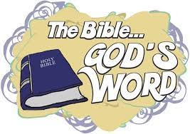Lectionary Scripture Readings
Reading the bible helps us develop and grow spiritually. We grow our relationship with God as we spend time with Him in prayer and in reading the Bible daily.
April 2, 2023 - Liturgy of the Palms
Matthew 21:1-11 - Psalm 118:1-2, 19-29
April 2, 2023 - Liturgy of the Passion Matthew 26:14-27:66 or
Matthew 27:11-54 - Isaiah 50:4-9a - Psalm 31:9-16 Philippians 2:5-11

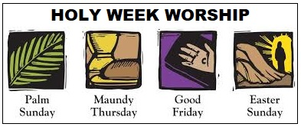
Sunday, April 2nd - Palm Sunday
Sunday Worship Service 10:30 AM.
All youth dismissed to classes after offertory.

Thursday, April 6th - Maundy Thursday Worship will be held at Frankford Memorial UMC (1300 Dyre Street, Phila, PA. 19124) beginning at 6:30 PM with a light Supper and the Service with Holy Communion beginning at 7:30 PM. Please contact Sue Creevey if you plan to attend so that we can plan how many will join us for the meal. Also, let Sue know if you need a ride. Sue Creevey 267-847-6029 ok to text.

Friday, April 7th - Good Friday Service here at Crescentville UMC 7:00 PM

Sunday, April 9th - Easter Sunday Sunday Worship Service 10:30 AM
All youth dismissed to classes after offertory.

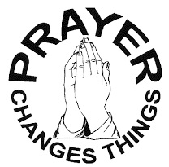
Joys & Concerns: Keep those prayers going and thank God for His answers! To add a prayer request or share a joy, please call the church and leave a message. (215) 745-7115. Our hearts are joined when we pray for others. It lets them know they are not alone, and they feel our love and compassion. No one forgets those who stood with them when life was tough or uncertain.

Prayer Requests from March 19, 2023

Stephen Matthias - Prayers for healing and for his family as he is in the hospital.
Martha Korto - Breast biopsy was positive for cancer. She had surgery on 3/13.
Prayers for healing and recovery.
Philip Lee - chest and shoulder pain - left ER against medical advise.
Cocoa Lee - eye surgery set for March 30th.
Harry (friend of Cocoa's) was in a bad accident, had multiple surgeries including foot amputation.
Prayers for recovery.
Dende - Thankful to be in Church today, thanks for prayers, messages and visits as she recovers
from shoulder surgery. Prayers for her as she is having a procedure on Monday.
JOY - Naiima Jabati received her drivers license.
Traveling mercies for Paul Wilson.
Prayers for those affected by the earthquake in Equidor.
Traveling mercies for Jean Jean.
Pastor's neice, Sarah - surgeries were successful, baby is fine, Sarah is home.
Continued prayers for Sarah, baby, and Jared.
Welcome to our guest, Violet.

Continuing Prayers:
Pastor Randy & Family Sana Aman Zilpha and James Browne Dorothy Buzzard
Eva Baumgartel Caroline (Burghaze’s Daughter) Patsy Coyne Rev. Khan Scott Meyer Marva Bob Patterson Cass Quigley Betty Sauerwald & family Wondor Korto Kayla McManus Sylvia Spotts Christian Stefenescu Suzanne Turner

Prayers for the Ukraine and Russia - for world peace
Prayers for our city and end to violence .
Prayers for peace and stability in Sierra Leone
Please praise and pray for our youth – they are the future of our Church!
As Pastor Randy will be retiring in July, we await the announcement of a new pastor to be assigned to our church. Please pray for the discernment of the cabinet as they select our new Pastor. Please also pray for our congregation that we move forward with joyful anticipation of these new beginnings.

TEA BY THE SEA Sunday, April 30, 2023 1:00 PM
Join us for afternoon tea and a presentation by
Sue Snyder featuring swimwear
from 1890 to the 1970’s

Admission $ 10.00 in advance$ 12.00 at the door
Please see Sue Snyder for tickets.

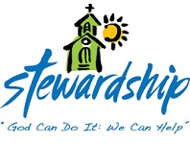 PLEASE prayerfully consider raising your weekly
monetary offering to help with our expenses.

Unsure if you are able to give more? Try taking a
up from your current giving, and if that goes well,
take another step – you may find that you can give more
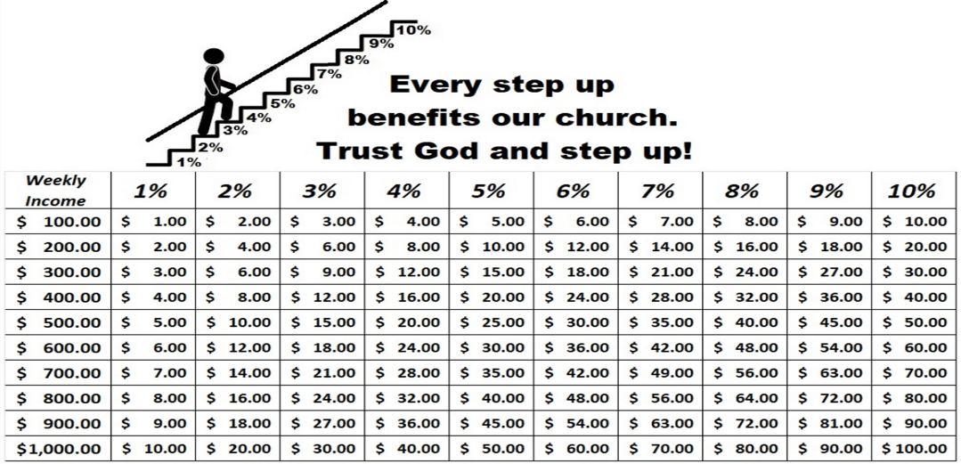 that you thought possible.

