July 26, 2026
9th Sunday after Pentecost
Special Guest: Rev. James Butler
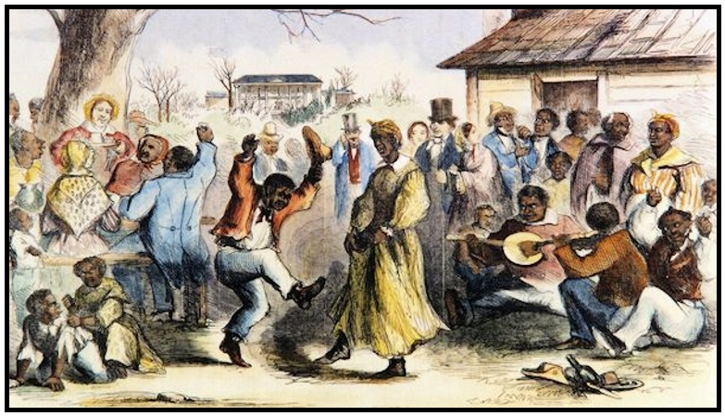
Crescentville United Methodist Church
A Changing Church for Changing Times
Rev. Lori Reyes
400 Sentner Street
Philadelphia, Pennsylvania 19120
215-745-7115
E-Mail: crescentvilleumc@gmail.com
Web Site: https://www.crescentvilleumc.com/
Facebook: https://www.facebook.com/crescentvilleumc
YouTube Channel:
https://www.youtube.com/@crescentvilleunitedmethodi7688

Crescentville United Methodist Church
9th Sunday after Pentecost July 26, 2026

PLEASE STAND AND SING AS WE BEGIN OUR TIME OF WORSHIP
“Sweet, Sweet Spirit”

Please be seated
Welcome and Announcements

Please stand
Chorus of Welcome “The Family of God” - Visit to Camp William Penn Museum
I’m so glad I’m a part of the family of God—I’ve been washed in the fountain, cleansed by His blood!
Joint heirs with Jesus as we travel this sod; for I’m part of the family, the family of God.

Call to Worship
L: Come with confidence before our God.
P: For nothing can separate us from the love of God.
L: Can hunger?
P: No!
L: Can hardship?
P: No!
L: Can people who are against us?
P: No!
L: Can death?
P: No!
L: Can anything in all creation?
P: No!…Then let us worship this most amazing God.

Opening Worship Song: “Reckless Love” Astravell Studios

Before I spoke a word, You were singing over me
You have been so, so good to me
Before I took a breath, You breathed Your life in me
You have been so, so good to me

Refrain
Oh, the overwhelming, never-ending, reckless love of God
Oh, it chases me down, fights 'til I'm found, leaves the 99
And I couldn't earn it, and I don't deserve it, still,
You give Yourself away
Oh, the overwhelming, never-ending, reckless love of God

When I was Your foe, still Your love fought for me
You have been so, so kind to me
When I felt no worth, You paid it all for me
You have been so, so kind to me Refrain

There's no shadow You won't light up
Mountain You won't climb up; Coming after me
There's no wall You won't kick down
Lie You won't tear down; Coming after me Refrain

Opening Prayer (In Unison)
Our gracious and ever loving God, we come in the midst of summer looking for refreshment. We rest in the knowledge of the wonderful works you have done for us, and of the deep and abiding love you have for us and for all God’s people. Search our hearts. Fill our soul with your indwelling Spirit who whispers to our soul that all will be well if we but trust in you. Shine your light before us,
that we may see our path to you and to your kingdom on earth. Amen.
Please Be Seated
Introduction to our hymn, “My Lord What A Morning”
Hymn: “My Lord What A Morning” UMH 719

Joys & Concerns - Today we will not have a time for spoken requests. Please write your joy or prayer request on the card in your pew and place it in the offering basket. Thank you.

Gifts and Offerings
Offertory “Oh, Give Thanks” Please join in singing!
Please stand
The Doxology “Praise God, From Whom All Blessings Flow” # 94
Praise God, from whom all blessings flow; praise God, all creatures here below: Alleluia! Alleluia!
Praise God, the source of all our gifts! Praise Jesus Christ, whose power uplifts!
Praise the Spirit, Holy Spirit! Alleluia! Alleluia! Alleluia!
The Offertory Prayer
Singing of THE LORD'S PRAYER–
Our Father, which art in heaven, hallowed be Thy name; Thy kingdom come, Thy will be done, on earth as it is in heaven. Give us this day our daily bread; and forgive us our debts as we forgive our debtors. And lead us not into temptation, but deliver us from evil. For Thine is the kingdom, and the power, and the glory, forever. Amen

Please be seated
Introduction to our hymn, “Swing Low Sweet Chariot”
Hymn: “Swing Low, Sweet Chariot” UMH # 703

Time of sharing from Sandy Heiser

Introduction to our hymn, “This Little Light of Mine”
Hymn: “This Little Light of Mine” UMH # 585

Time of sharing from Naaima Jabati

Introduction to our hymn, “Lift Every Voice and Sing”
Hymn: “Lift Every Voice and Sing” UMH # 519

Benediction

Choral Benediction “Reckless Love” Astravell Studios
Refrain
Oh, the overwhelming, never-ending, reckless love of God
Oh, it chases me down, fights 'til I'm found, leaves the 99
And I couldn't earn it, and I don't deserve it, still,
You give Yourself away
Oh, the overwhelming, never-ending, reckless love of God

AUGUST BIRTHDAYS - We will celebrate these birthdays next Sunday

01 Cass Cassiano 13 Joan Potts
01 Sue Creevey 18 Gene Saloky
02 John Combay 18 Cocoa Lee
05 Sherma Prince 21 Wendy Farrer
05 Diana Wilson 27 Jake Lee
08 Mallory Jean 28 Jean Bernard
08 Jacob Monbo Sr 28 Daniela Stefanescu
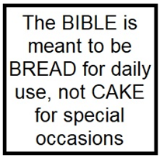
Lectionary Scripture Readings
Reading the Bible teaches us how to treat each other as God intended. The world teaches a “me first” mindset. We exalt self over service and so find it difficult to treat others with respect or love. When we read the Bible, we learn how God wants us to treat each other. We also see the result of following His ways…and of disobedience.
August 02, 2026 – 10th Sunday after Pentecost
- Matthew 14:13-21 - Genesis 32:22-31 and Psalm 17:1-7, 15 - Romans 9:1-5

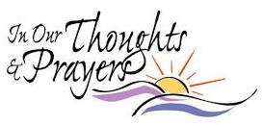
Joys & Concerns: Keep those prayers going and thank God for His answers! To add a prayer request or share a joy,
please call or text Sue Creevey 267-847-6029

Prayer Requests from July 19, 2026
Traveling mercies for Kim & Demitri as they honeymoon in Greece
Jean Bernard asks for prayers for his family.
Prayers of healing for Keri Sander
Prayers of healing for Lee & John Waldner
Prayers for Patrick & Stacy Bresnan
Continuing Prayers for:
Martha & Wondor Korto Sheryl Duke David & Esther Clinton Amber Sarkar
Tracey & Bill Lewis Pastor Lori Lori Rovevelli Robert Smith
Walter Rininsland (Joan Pott's Dad) Crescentville UMC
Prayers for those living with constant pain and other ailments.
For those who are sick, and those that grieve. For those who live in war zones and poverty.

For families, especially:
Zilpha and James Browne, The Stefanescu, Mc Manus, Salvadore, and Didirea Families, Jean Bernard and family, The Spotts Family, Bresnan Family

For an end to violence, for peace and stability
Philadelphia, especially our community - Sierra Leone, Africa
Haiti - Israel and Hamas - Ukraine and Russia

Please praise and pray for our youth – they are the future of our church!

UPCOMING EVENTS

Next Sunday, August 2nd, is Holy Communion Sunday.
A second offering will be collected, and funds will go to our youth program.

Saturday, August 15th, Crescentville Summer Flea Market. 9 AM – 1 PM

