September 21, 2025
15th Sunday after Pentecost
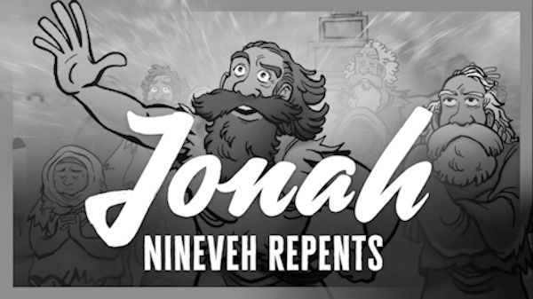

Crescentville United Methodist Church
A Changing Church for Changing Times
Pastor Rev. Lori Reyes
400 Sentner Street
Philadelphia, Pennsylvania 19120
215-745-7115
E-Mail: crescentvilleumc@gmail.com
Web Site: https://www.crescentvilleumc.com/
Facebook: https://www.facebook.com/crescentvilleumc
YouTube Channel:
https://www.youtube.com/@crescentvilleunitedmethodi7688

Crescentville United Methodist Church

15th Sunday after Pentecost September 21, 2025
Prelude
PLEASE STAND AND JOIN IN SINGING “Sweet, Sweet Spirit”

Welcome & Announcements

Please stand
Chorus of Welcome “The Family of God”
I’m so glad I’m a part of the family of God—I’ve been washed in the fountain, cleansed by His blood! Joint heirs with Jesus as we travel this sod; for I’m part of the family, the family of God.

Call to Worship
L: We gather this day in silence and hope
P: as we listen for God’s word to us.
L: Let your hearts and spirits be open.
P: for God is speaking.
L: Be still
P: With willing hearts and spirits, we wait for the Lord.

Opening Praise Song “Reckless Love” Song by Bethel Music & Cory Asbury

Before I spoke a word, You were singing over me
You have been so, so good to me
Before I took a breath, You breathed Your life in me
You have been so, so kind to me

Refrain
Oh, the overwhelming, never-ending, reckless love of God
Oh, it chases me down, fights 'til I'm found, leaves the 99
And I couldn't earn it, and I don't deserve it, still,
You give Yourself away
Oh, the overwhelming, never-ending, reckless love of God

When I was Your foe, still Your love fought for me
You have been so, so good to me
When I felt no worth, You paid it all for me
You have been so, so kind to me Refrain

There's no shadow You won't light up
Mountain You won't climb up; Coming after me
There's no wall You won't kick down
Lie You won't tear down; Coming after me Refrain

Opening Prayer
Forgiving God, we repent of all the ways we turn from you. You call but we do not listen; you show us your path but we prefer our own way. Forgive us, heal us, and lead us back to you. We pray that in our hearing, we might truly listen and trust in you. In Jesus name, we pray. Amen.

Please Be Seated
Youth Message

Joys & Concerns……………Gathered Prayer

Singing of the Lord’s Prayer - Our Father, which art in heaven, hallowed be Thy name; Thy kingdom come, Thy will be done, on earth as it is in heaven. Give us this day our daily bread; and forgive us our debts as we forgive our debtors. And lead us not into temptation but deliver us from evil. For Thine is the kingdom, and the power, and the glory, forever. Amen

Gifts and Offerings

Offertory “God Whose Giving Knows No End” Please join in singing!
Please stand
The Doxology “Praise God, From Whom All Blessings Flow” # 95
Praise God, from whom all blessings flow; praise God, all creatures here below; praise God above,
ye heavenly host; praise Father, Son, and Holy Ghost. Amen.

The Offertory Prayer

Dismissal of the Youth

Hymn God Will Take Care of You # 130

Be not dismayed whate’er betide, God will take care of you;
Beneath His wings of love abide, God will take care of you.

Refrain:
God will take care of you, through every day, o’er all the way;
He will take care of you, God will take care of you.

Through days of toil when heart doth fail, God will take care of you.
When dangers fierce your path assail, God will take care of you. [Refrain]

All you may need He will provide, God will take care of you;
Nothing you ask will be denied, God will take care of you. [Refrain]

No matter what may be the test, God will take care of you;
Lean, weary one, upon His breast, God will take care of you. [Refrain]

Please be seated
Gospel Lesson Jonah 3 1-10 [NRSV}
Conversion of Nineveh
The word of the Lord came to Jonah a second time, saying, ² “Get up, go to Nineveh, that great city, and proclaim to it the message that I tell you.” ³ So Jonah set out and went to Nineveh, according to the word of the Lord. Now Nineveh was an exceedingly large city, a three days’ walk across. ⁴ Jonah began to go into the city, going a day’s walk. And he cried out, “Forty days more, and Nineveh shall be overthrown!” ⁵ And the people of Nineveh believed God; they proclaimed a fast, and everyone, great and small, put on sackcloth.
⁶ When the news reached the king of Nineveh, he rose from his throne, removed his robe, covered himself with sackcloth, and sat in ashes^{. 7} Then he had a proclamation made in Nineveh: “By the decree of the king and his nobles: No human or animal, no herd or flock, shall taste anything. They shall not feed, nor shall they drink water. ⁸ Humans and animals shall be covered with sackcloth, and they shall cry mightily to God. All shall turn from their evil ways and from the violence that is in their hands. ⁹ Who knows? God may relent and change his mind; he may turn from his fierce anger, so that we do not perish.”
¹⁰ When God saw what they did, how they turned from their evil ways, God changed his mind about the calamity that he had said he would bring upon them, and he did not do it.

Sermon “He Will Never Give Up on Us”

Please stand
Affirmation of Faith The Apostles’ Creed
I believe in God the Father Almighty, maker of heaven and earth;
And in Jesus Christ His only Son our Lord:
who was conceived by the Holy Spirit, born of the Virgin Mary,
suffered under Pontius Pilate, was crucified, dead, and buried;
the third day He rose from the dead; He ascended into heaven,
and sitteth at the right hand of God the Father Almighty;
from thence He shall come to judge the quick and the dead;

I believe in the Holy Spirit, the holy catholic church,
the communion of saints, the forgiveness of sins,
the resurrection of the body, and the life everlasting. Amen.

Please remain standing
Closing Hymn “Sent Forth by God’s Blessing” # 664

Sent forth by God’s blessing, our true faith confessing,
the people of God from this dwelling take leave.
The service is ended, O now be extended
the fruits of our worship in all who believe.
The seed of the teaching, receptive souls reaching,
shall blossom in action for God and for all.
God’s grace did invite us, and love shall unite us
to work for God’s kingdom and answer the call.

With praise and thanksgiving to God ever living,
the tasks of our everyday life we will face.
Our faith ever sharing, in love ever caring,
embracing God’s children of each tribe and race.
With Your grace You feed us, with Your light now lead us;
unite us as one in this life that we share.
Then may all the living with praise and thanksgiving
Give honor to Christ and that name which we bear.

Benediction
Choral Benediction “Reckless Love” [refrain only]
Oh, the overwhelming, never-ending, reckless love of God
Oh, it chases me down, fights 'til I'm found, leaves the 99
And I couldn't earn it, and I don't deserve it, still, You give Yourself away
Oh, the overwhelming, never-ending, reckless love of God


Lectionary Scripture Readings
When we eat spiritual food we’re supplied to live our Christian life. But when we’re away from God’s Word for a while, we can become spiritually weak, tired, and “grumpy,” or, unable to handle difficulties well. We become more susceptible to temptation, doubts, and other kinds of spiritual sickness. We simply don’t have the means to cope with the many challenges that come into our lives as believers. It’s very important, therefore, that we’re supplied by reading and feeding on God’s Word every day. To maintain a healthy and even joyful Christian life, we need daily Bible reading to receive the spiritual nourishment in God’s Word for us.
September 28, 2025 – 16th Sunday after Pentecost
Luke 16:19-31 - Jeremiah 32:1-3a, 6-15 - Psalm 91:1-6, 14-16 - 1 Timothy 6:6-19

Joys & Concerns: Keep those prayers going and thank God for His answers! To add a prayer request or share a joy, please call or text Sue Creevey 267-847-6029
Our prayers display trust in God, our belief in Christ, and when prayers are answered, we praise Him for his faithfulness. Our prayers glorify God. Praying is not just a conversation. Prayer is praise for the work God will do through our prayers. He has delivered us from such a deadly peril, and he will deliver us again.

Prayer Request from September 14th
PLEASE NOTE THAT IF YOUR PRAYER REQUEST WAS NOT ENTERED ON A PRAYER CARD,
IT IS NOT LISTED HERE. They can be viewed on the September 14th Worship Video.

Traveling mercies for Paul Wilson, Ally settled in NY and looking for a job, Andrew moved to Pittsburgh and has a new job.
Prayers for the Davidson family as they mourn the death of Joe Davidson.
Claudia has a new grandson, Corneilius George Jr. Traveling mercies for Claudia.
Prayers for Ginny & Al Pierson. Al has major heart issues.
Prayers for the Koroma Family as they mourn the death of Celine.
Prayers for the Patrick family as they mourn the death of Jerry Patrick.
Continued prayers for Theresa Kargo as she still is not having relief from pain.
Prayers for Jean Jaques Jean as he was in the ER this week.
Prayers for Trecia Sandford
Prayers of healing for Ernest Martin (in hospital)
Prayers for Allyson Jenkins for healing of her legs. Thank you for all prayers for Frank, his surgery went well.
Healing prayers for Keri & John
Prayers for Ryan for business success.
JOY - Welcome to new neighbors, Josette and Evona as they join us for worship.
Continuing Prayers for:
Martha & Wondor Korto Scott Meyer Sheryl Duke David & Esther Clinton
Tracey & Bill Lewis Jennifer Prayers for our Pastor Lori and our congregation.
For families, especially:
Zilpha and James Browne, The Stefanescu, Mc Manus, Salvadore, and Didirea Families,
Jean Bernard and family, The Spotts Family, Bresnan Family
For an end to violence, for peace and stability
Philadelphia, especially our community - Sierra Leone, Africa
Haiti - Israel and Hamas - Ukraine and Russia
Please praise and pray for our youth – they are the future of our church!
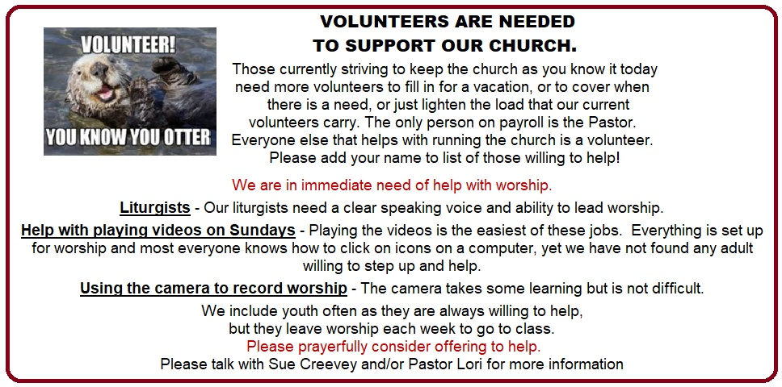
UPCOMING EVENTS


Baptism and membership classes will be on September 14th and 21st, following the worship service. Baptism and membership will be celebrated during worship on Sept 28th.




