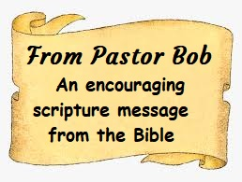
A man of knowledge uses words with restraint,
and a man of understanding is even tempered.
Even a fool is thought wise if he keeps silent,
and discerning if he holds his tongue.
(Proverbs 17:27-28)

Crescentville & Frankford Memorial United Methodist Churches

14th Sunday after Pentecost September 6, 2020

Welcome

Chorus of Welcome “The Family of God”
I’m so glad I’m a part of the family of God—I’ve been washed in the fountain, cleansed by His blood!
Joint heirs with Jesus as we travel this sod; for I’m part of the family, the family of God.

Call to Worship based on Romans 13: 8-14 and Matthew 18: 15-20
People of God, open your eyes! Look around! The presence of our Lord Jesus Christ is here –
among us and within us. God’s salvation is close at hand, nearer than you know. So open
your hearts and minds to the Spirit, and let’s worship God together!

Opening Hymn “I Come With Joy” # 617 – Tune: LAND OF REST # 269
I come with joy to meet my Lord, forgiven, loved and free,
In awe and wonder to recall His life laid down for me.

I come with Christians far and near to find, as all are fed,
The new community of love in Christ’s communion bread.

As Christ breaks bread and gives us share each proud division ends.
That love that made us makes us one and strangers now are friends,

And thus with joy we meet our Lord, His presence always near,
Is in such friendship better known: we see and praise Him here,

Opening Prayer
Lord of the church, you call a broken people around your table: in times of disagreement
teach us to listen, loose us from prejudice and bind us to your way of forgiving grace;
through Jesus Christ, who stands at the heart of our gathering. Amen.

Children’s Message Sue Snyder

Joys & Concerns

Gathered Prayer

Hymn: “The Lord’s Prayer”

Our Father, who art in heaven, hallowed be Thy name; Thy kingdom come, Thy will be done,
on earth as it is in heaven. Give us this day our daily bread; and forgive us our debts
as we forgive our debtors, And lead us not into temptation, but deliver us from evil.
For Thine is the kingdom, and the power, and the glory, forever. Amen.

Gifts and Offerings

The Doxology “Praise God, From Whom All Blessings Flow”

Praise God from whom all blessings flow, Praise Him all creatures here below,

Praise Him above, ye heavenly host; praise Father, Son, and Holy Ghost. Amen.

The Offertory Prayer
Hymn “Living Water Bread of Life”
Like a deer, panting for the water I was thirsting for so long, I was so dry
So I set out on my journey, not sure what I would find
But I found an everlastin' river of life
Ooh, it's just like fallin' rain I will never thirst again

Living Water, Bread of Life Come and quench this thirst within me
Fill this hunger deep inside For so long I have been empty Nothing else will satisfy
You alone are what I need, Lord……. Living Water, Bread of Life

I had looked this whole world over for the answer
Wanting just to fill this void inside
All the things that were material, they could not satisfy
For my hungering was for the Bread of Life
Ooh, it came like manna from above I can never get enough

Living Water, Bread of Life Come and quench this thirst within me
Fill this hunger deep inside For so long I have been empty Nothing else will satisfy
You alone are what I need, Lord…….Living Water, Bread of Life

Gospel Lesson Matthew 18:15-20
15 “If your brother or sister sins, go and point out their fault, just between the two of you. If they listen to you, you have won them over. 16 But if they will not listen, take one or two others along, so that ‘every matter may be established by the testimony of two or three witnesses.’17 If they still refuse to listen, tell it to the church; and if they refuse to listen even to the church, treat them as you would a pagan or a tax collector.
18 “Truly I tell you, whatever you bind on earth will be bound in heaven, and whatever you loose on earth will be loosed in heaven.
19 “Again, truly I tell you that if two of you on earth agree about anything they ask for, it will be done for them by my Father in heaven. 20 For where two or three gather in my name, there am I with them.”

Sermon "Restoration" Pastor Bob

Affirmation of Faith The Apostles’ Creed

I believe in God the Father Almighty, maker of heaven and earth;

And in Jesus Christ His only Son our Lord: who was conceived
by the Holy Spirit, born of the Virgin Mary,
suffered under Pontius Pilate, was crucified, dead, and buried;
the third day He rose from the dead; He ascended into heaven,
and sitteth at the right hand of God the Father Almighty;
from thence He shall come to judge the quick and the dead;

I believe in the Holy Spirit, the holy catholic church,
the communion of saints, the forgiveness of sins,
the resurrection of the body, and the life everlasting. Amen.

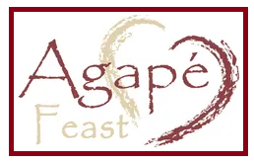
Gather your own symbolic elements, and Pastor Bob will indicate when we eat and drink together, even though apart.

Prayer ( This prayer was written by Charles Wesley especially for the Love Feast and recommended for use at all Love Feasts by both John and Charles Wesley.)

Father of earth and heaven, Thy hungry children feed, Thy grace be to our spirits given, That true immortal bread. Grant us and all our race, In Jesus Christ to prove, The sweetness of Thy pardoning grace, The manna of thy love. Amen

(Ready, and honor, our symbols.)

Be present at our table, Lord; be here and everywhere adored;
Your creatures bless, and grant that we may feast in paradise with Thee.

(Eat together. Drink at the same time.)

Your love, O God, has called us here, for all love finds its source in you, the perfect love that casts out fear, the love that Christ makes ever new. O gracious God, you consecrate all that is lovely, good and true. Bless those who in your presence wait and every day their love renew. O God of love, inspire our life, reveal your will in all we do; join every husband, every wife in mutual love and love for you.

Hymn “In Christ Alone”
In Christ alone my hope is found, He is my light, my strength, my song
This Cornerstone, this solid Ground, firm through the fiercest drought and storm.
What heights of love, what depths of peace. When fears are stilled, when strivings cease.
My Comforter, my All in All. Here in the love of Christ I stand.

In Christ alone! - who took on flesh, fullness of God in helpless babe.
This gift of love and righteousness, scorned by the ones He came to save
Till on that cross as Jesus died, the wrath of God was satisfied
For every sin on Him was laid. Here in the death of Christ I live.

There in the ground His body lay…. Light of the world by darkness slain:
Then bursting forth in glorious day, up from the grave He rose again
And as He stands in victory, sin's curse has lost its grip on me…
For I am His and He is mine, bought with the precious blood of Christ.

No guilt in life, no fear in death, this is the power of Christ in me
From life's first cry to final breath, Jesus commands my destiny
No power of hell, no scheme of man, can ever pluck me from His hand……
Till He returns or calls me home, here in the power of Christ I'll stand.
In Christ alone…In Christ alone!

Benediction

Choral Benediction “Go In Peace To Love And Serve The Lord” Chris Brunelle
Go In peace to love and serve the Lord. Go in peace become the living Word.
Christ on our lips and Christ in our hearts, may we show God’s love to the world, to the world.
May we show God’s love to the world


Lectionary scripture readings:

Sunday, June 21st Matthew 10:24-39 - Genesis 21:8-21 – Psalm 86:1-10, 16-17 or Psalm 17 - Romans 6:1b-11

Sunday, June 28th Matthew 10:40-42 - Genesis 22:1-14 - Psalm 13 - Romans 6:12-23

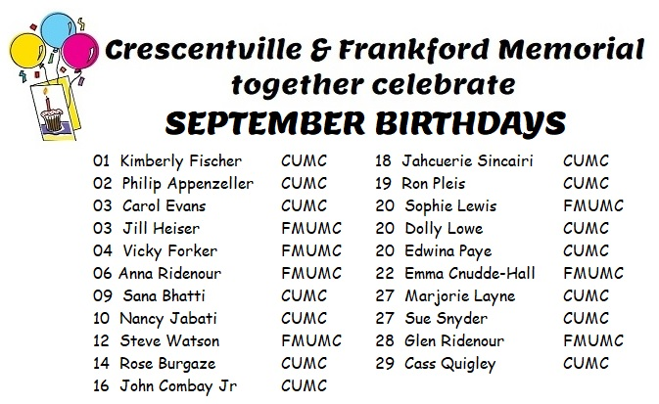


To continue the ministry of our church even as we are not able to use the building for our worship, please take the time to send your tithes and offerings to our Church office:
412 Sentner Street, Philadelphia, PA 19120
THANK YOU TO ALL WHO CONTINUE TO SEND IN
OR DROP OFF OFFERINGS AND TITHES!

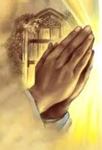
Please remember to call the church office with your prayer requests or to share a joy. Also, let us know if you need to have someone keep in touch with you to keep you updated on Crescentville UMC.
To add a prayer request or share a joy, please email the church at crescentvilleumc@gmail.com, or call the church and leave a message.
(215) 745-7115.

