*We know that to be physically healthy requires us to eat a diet of foods that are nutritious and beneficial to our physical bodies. In today’s Gospel Lesson we hear Jesus speaking about our spiritual health and our need to fill ourselves with what He offers. The passage is clear that to fill ourselves with Jesus is not easy, and yet is what leads to the fullness of life that God has for us all, if we but commit ourselves to such a diet.*

*- Pastor Randy*

***Crescentville & Frankford Memorial United Methodist Churches***

**13th Sunday After Pentecost August 22, 2021**

**Welcome**

Chorus of Welcome *“The Family of God”*

I’m so glad I’m a part of the family of God—I’ve been washed in the fountain, cleansed by His blood!

Joint heirs with Jesus as we travel this sod; for I’m part of the family, the family of God.

**Call to Worship** *Psalm 84*

*One day spent in [God’s] temple is better than a thousand anywhere else; I would rather stand*

*at the gate of the house of my God than live in the homes of the wicked. The Lord is our protector*

*and glorious king, blessing us with kindness and honor. God does not refuse any good thing*

*to those who do what is right……How happy are those who trust in God!*

**Opening Hymn** *“I Love Thy Kingdom, Lord”* [VS. 1-4]# 540

I love thy kingdom, Lord, the house of thine abode,

the church our blest Redeemer saved with his own precious blood.

I love thy church, O God! Her walls before thee stand  
dear as the apple of thine eye, and graven on thy hand.

For her my tears shall fall, for her my prayers ascend,  
to her my cares and toils be given, till toils and cares shall end.

Beyond my highest joy I prize her heavenly ways,  
her sweet communion, solemn vows, her hymns of love and praise.

**Opening Prayer**

**Grant, O merciful God, that Your Church, being gathered together in unity by Your Holy Spirit,**

**may show forth Your power among all peoples, to the glory of Your Name; through Jesus Christ**

**our Lord, who lives and reigns with You and the Holy Spirit, one God, for ever and ever. Amen.**

**Children’s Message**

**Joys & Concerns………………….……..*Gathered Prayer…………………………The Lord’s Prayer***

*Our Father, who art in heaven,**hallowed be Thy name;**Thy kingdom come, Thy will be done,*

*on earth as it is in heaven.**Give us this day our daily bread; and forgive us our trespasses and debts as we forgive our debtors and those who trespass**against us. And lead us not into temptation,*

*but deliver us from evil. For Thine is the kingdom, and the power, and the glory, forever. Amen.*

Gifts and Offerings The Doxology

*“Praise God, From Whom All Blessings Flow” # 95*

Praise God, from whom all blessings flow; praise Him, all creatures here below;  
praise Him above, ye heavenly host; praise Father, Son, and Holy Ghost. Amen.

**The Offertory Prayer**

**Hymn** *“Standing on the Promises”* [VS. 1-3]# 374

Standing on the promises of Christ my King, through eternal ages let his praises ring;  
glory in the highest, I will shout and sing, standing on the promises of God.

*Refrain:* Standing, standing, standing on the promises of God my Savior;

standing, standing, I'm standing on the promises of God.

Standing on the promises that cannot fail, when the howling storms of doubt and fear assail,  
by the living Word of God I shall prevail, standing on the promises of God. *Refrain*

Standing on the promises of Christ the Lord, bound to him eternally by love's strong cord,  
overcoming daily with the Spirit's sword, standing on the promises of God. *Refrain*

**Gospel Lesson** *St. John 6:56-69*

[Jesus said] “Whoever eats my flesh and drinks my blood remains in me and I in them.

**57**As the living Father sent me, and I live because of the Father, so whoever eats me lives

because of me. **58**This is the bread that came down from heaven. It isn’t like the bread

your ancestors ate, and then they died. Whoever eats this bread will live forever.”

**59**Jesus said these things while he was teaching in the synagogue in Capernaum.

**60**Many of his disciples who heard this said, “This message is harsh. Who can hear it?”

**61**Jesus knew that the disciples were grumbling about this and he said to them,

“Does this offend you? **62**What if you were to see the Human One going up where he was before?

**63**The Spirit is the one who gives life and the flesh doesn’t help at all. The words I have spoken to you

are spirit and life. **64**Yet some of you don’t believe.” Jesus knew from the beginning who wouldn’t believe

and the one who would betray him. **65**He said, “For this reason I said to you that none can come to me

unless the Father enables them to do so.” **66**At this, many of his disciples turned away

and no longer accompanied him.

**67**Jesus asked the Twelve, “Do you also want to leave?”

**68**Simon Peter answered, “Lord, where would we go? You have the words of eternal life.

**69**We believe and know that you are God’s holy one.”

**Sermon** *“You Are What You Eat”*

**Affirmation of Faith** *The Apostles’ Creed*

I believe in God the Father Almighty, maker of heaven and earth;

And in Jesus Christ His only Son our Lord: who was conceived

by the Holy Spirit, born of the Virgin Mary,

suffered under Pontius Pilate, was crucified, dead, and buried;

the third day He rose from the dead; He ascended into heaven,

and sitteth at the right hand of God the Father Almighty;

from thence He shall come to judge the quick and the dead;

I believe in the Holy Spirit, the holy catholic church,

the communion of saints, the forgiveness of sins,

the resurrection of the body, and the life everlasting. Amen.

**Hymn**  *“I Know Whom I Have Believed”* [VS. 1-3]# 714

I know not why God's wondrous grace to me he hath made known,  
 nor why, unworthy, Christ in love redeemed me for his own.

*Refrain:* But I know whom I have believed, and am persuaded that he is able  
 to keep that which I've committed unto him against that day.

I know not how this saving faith to me he did impart,  
nor how believing in his word wrought peace within my heart. *Refrain*

I know not how the Spirit moves, convincing man of sin,  
revealing Jesus through the word, creating faith in him. *Refrain*

**Benediction**

***Quiet Meditation, Reflection, and Prayer***

**Choral Benediction**   *“Standing on the Promises”* [VS. 4]# 374

Standing on the promises I cannot fall, listening every moment to the Spirit’s call,

resting in my Savior as my all in all, standing on the promises of God. Standing, standing,

standing on the promises of God my Savior; standing, standing, I’m standing on the promises of God.

**Lectionary Readings**



When we read and study the Bible, it nourishes the soul and invigorates our relationships with God. Imagine going without food for days; your body would become weaker and weaker. Nourishment is necessary for our survival and this extends to our spirituality as well.

**Sunday, Aug 29 14th Sunday after Pentecost**

Mark 7:1-8, 14-15, 21-23 - Song of Solomon 2:8-13,

Psalm 45:1-2, 6-9 or Psalm 72 795) - James 1:17-27

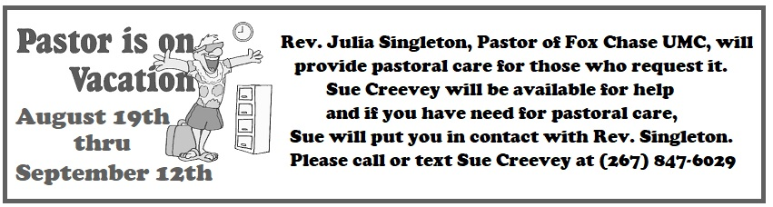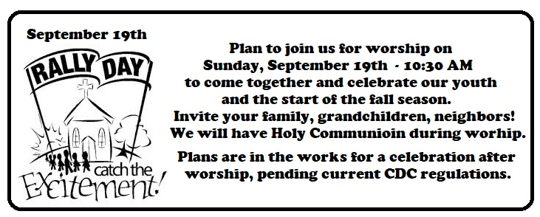

***JOYS AND CONCERNS***

*Praying for one another is a powerful way for us to bear one another’s burdens. It is a loving act to pray for someone and join them in taking the pain of their heart to God.*

*8/15/2021*

**For Sierra Leone UM Conference**, that has been without a resident Bishop for one year. Prayers that one can be elected.

**Traveling mercies for all that are traveling**, especially Pastors Randy & Cindy, Paul Wilson & Family, and Wadiya Korpoi.

**Sarah Coker-Macauley** (Collingwoode’s Mom) prayers for good health

Prayers for all **health care workers** as Covid cases surge once again.

**For Hatti** – Our member from Hatti, Jean Bernard says that his family in Hatti was well away from the earthquake and they are doing well.

***JOY*** – We had visitors, Bill & Terry Meecham, Bill’s family was originally from Crescentville.

**Continuing Prayers:**

|  |  |  |
| --- | --- | --- |
| Pastor Randy & Family | Jim Creevey | Betty Sauerwald & family |
| Caroline (Burghaze’s Daughter) | Fred Frank | Sylvia Spotts |
| Sana Aman | Rev. Khan | Edith Uhlman |
| Zilpha Browne | Scott Meyer | John & Diana Wilson |
| Dorothy Buzzard | Cass Quigley |  |

We pray for the world around us, for the many who continue to suffer and call out for help, for those without enough to eat, for those caught up in violence and political uprisings, for those picking up the pieces after a natural disaster, and for those desperate to find work to support their families.

