Today, Jesus challenges us as to who, or what is most important. By speaking of how our love and devotion to Him must make our love and care for our families and even ourselves, appear as hatred, Jesus makes it hard to believe. Yet, as He speaks in terms of us carrying our own crosses, or dying to self, He uses the image of how He will soon do that very thing—willingly carry a cross to show His selfless act of love for the world. Seeing it this way, our belief shows in how willing we are to share ALL of what God has given to us. – Pastor Randy

Crescentville & Frankford Memorial United Methodist Churches

Thirteenth Sunday after Pentecost I believe… September 4, 2022

Welcome

Chorus of Welcome “The Family of God”
I’m so glad I’m a part of the family of God—I’ve been washed in the fountain, cleansed by His blood!
Joint heirs with Jesus as we travel this sod; for I’m part of the family, the family of God.

Call to Worship Isaiah 43

……the Lord says, “Do not cling to events of the past or dwell on what happened long ago.
Watch for the new thing I am going to do. It is happening already—you can see it now!
I will make a road through the wilderness and give you streams of water there.
Even the wild animals will honor me; jackals and ostriches will praise me
when I make rivers flow in the desert to give water to my chosen people.
They are the people I made for myself, and they will sing my praises!”

Opening Hymn “This Is a Day of New Beginnings” [VS. 1-3] # 383

This is a day of new beginnings, time to remember and move on,
time to believe what love is bringing, laying to rest the pain that's gone.

For by the life and death of Jesus, God's mighty Spirit, now as then,
can make for us a world of difference, as faith and hope are born again.

Then let us, with the Spirit's daring, step from the past and leave behind
our disappointment, guilt, and grieving, seeking new paths, and sure to find.

Opening Prayer

Grant us, O Lord, to trust You with all our hearts; for, as You always resist the proud
who confide in their own strength, so You never forsake those who make their boast
of Your mercy; through Jesus Christ our Lord, who lives and reigns with You
and the Holy Spirit, one God, now and for ever. Amen.

Children’s Message

Joys & Concerns………………….……..Gathered Prayer

Gifts and Offerings The Doxology

“Praise God, From Whom All Blessings Flow” # 95

Praise God, from whom all blessings flow; praise Him, all creatures here below;
praise Him above, ye heavenly host; praise Father, Son, and Holy Ghost. Amen.

The Offertory Prayer

Hymn “We Believe in One True God” # 85

We believe in one true God, Father, Son, and Holy Ghost, ever present help in need,
praised by all the heavenly host; by whose mighty power alone all is made and wrought and done.

We believe in Jesus Christ, Son of God and Mary's Son, who descended from his throne
and for us salvation won; by whose cross and death are we rescued from sin's misery.

We confess the Holy Ghost, who from both fore'er proceeds; who upholds and comforts us
in all trials, fears, and needs. Blest and Holy Trinity, praise forever be to Thee!

Gospel Lesson St. Luke 14:25-33

Large crowds were traveling with Jesus. Turning to them, he said, ²⁶ “Whoever comes to me
and doesn’t hate father and mother, spouse and children, and brothers and sisters—
yes, even one’s own life—cannot be my disciple.
²⁷ Whoever doesn’t carry their own cross and follow me cannot be my disciple.
²⁸ “If one of you wanted to build a tower, wouldn’t you first sit down and calculate the cost,
to determine whether you have enough money to complete it? ²⁹ Otherwise, when you have laid
the foundation but couldn’t finish the tower, all who see it will begin to belittle you. ³⁰ They will say,
‘Here’s the person who began construction and couldn’t complete it!’ ³¹ Or what king would go to war
against another king without first sitting down to consider whether his ten thousand soldiers
could go up against the twenty thousand coming against him? ³² And if he didn’t think he could win,
he would send a representative to discuss terms of peace while his enemy was still a long way off.
³³ In the same way, none of you who are unwilling to give up all of your possessions can be my disciple.

Sermon “How Much is All?”

“I believe…” Angelina Cole & Marina Jean

Affirmation of Faith The Apostles’ Creed

I believe in God the Father Almighty, maker of heaven and earth;
And in Jesus Christ His only Son our Lord: who was conceived
by the Holy Spirit, born of the Virgin Mary,
suffered under Pontius Pilate, was crucified, dead, and buried;
the third day He rose from the dead; He ascended into heaven,
and sitteth at the right hand of God the Father Almighty;
from thence He shall come to judge the quick and the dead;

I believe in the Holy Spirit, the holy catholic church,
the communion of saints, the forgiveness of sins,
the resurrection of the body, and the life everlasting. Amen.

Service of Holy Communion

The Lord be with you…………………...…And also with you.
Lift up your hearts……………………...…..We lift them up to the Lord.
Let us give thanks to the Lord our God….It is right to give God thanks and praise.

...And so, with your people on earth and all the company of heaven
we praise your name and join their unending hymn:

HOLY, HOLY, HOLY LORD, GOD OF POWER AND MIGHT, HEAVEN
AND EARTH ARE FULL OF YOUR GLORY, HOSANNA IN THE
HIGHEST. BLESSED IS HE WHO COMES IN THE NAME OF THE
LORD. HOSANNA IN THE HIGHEST.

...And so, in remembrance of these your mighty acts in Jesus Christ,
we offer ourselves in praise and thanksgiving as a holy and living sacrifice,
in union with Christ’s offering for us, as we proclaim the mystery of faith.

CHRIST HAS DIED; CHRIST IS RISEN, CHRIST WILL COME AGAIN.

...Through your Son Jesus Christ, with the Holy Spirit in your holy Church,
all glory and honor is yours, almighty God, now and for ever. AMEN.

THE LORD'S PRAYER--Our Father, who art in heaven, hallowed be Thy name; Thy kingdom come,
Thy will be done, on earth as it is in heaven. Give us this day our daily bread;
and forgive us our trespasses and debts as we forgive our debtors and those who
trespass against us. And lead us not into temptation, but deliver us from evil.
For Thine is the kingdom, and the power, and the glory, forever. Amen.

BREAKING THE BREAD………………………………….GIVING THE BREAD AND CUP

Communion Hymn ”Jesus Paid It All”

PRAYER AFTER COMMUNION

God of all mercy, in this meal You have set aside our sins and You have given us Your healing:
grant that we how are made whole in Christ may bring that healing to this broken world,
in the name of Jesus Christ our Lord. Amen.

Hymn “Where He Leads Me” [VS. 1-3] # 338

I can hear my Savior calling, I can hear my Savior calling,
I can hear my Savior calling, "Take thy cross and follow, follow me."

Refrain: Where He leads me I will follow, where He leads me I will follow,
where He leads me I will follow; I'll go with Him, with Him all the way.

I'll go with Him through the garden, I'll go with Him through the garden,
I'll go with Him through the garden, I'll go with Him, with him all the way. Refrain

I'll go with Him through the judgment, I'll go with Him through the judgment,
I'll go with Him through the judgment, I'll go with Him, with him all the way. Refrain

Benediction
Quiet Meditation, Reflection, and Prayer

Choral Benediction “I Know Whom I Have Believed” [VS. 3] # 714

I know not how the Spirit moves, convincing us of sin,
revealing Jesus through the word, creating faith in Him.
But I know whom I have believed, and am persuaded that He is able
to keep that which I've committed unto Him against that day.
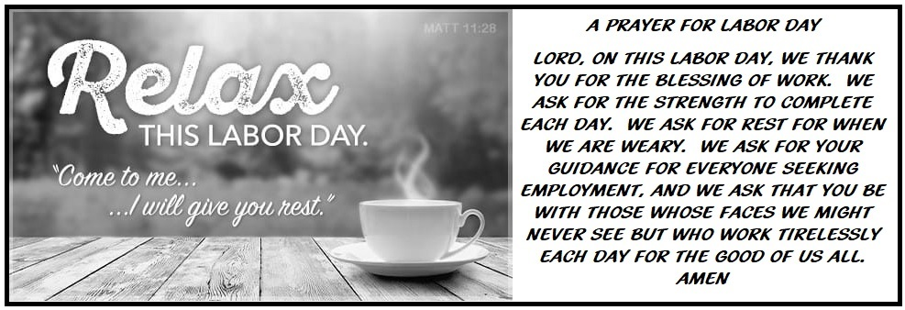

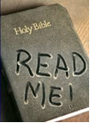
Lectionary Scripture Readings
We can get very caught up in our religion. We can go through all the motions that religion dictates, but it means nothing without faith. When we read our Bible, we open ourselves up to remembering our faith. We read stories of others who have demonstrated real faith, and sometimes we also are reminded of what happens when we lose our faith. Yet the Word of God reminds us that He is our focus.
September 11, 2022 – 14th Sunday after Pentecost
Luke 15:1-10 - Jeremiah 4:11-12, 22-28 - Psalm 14 - 1 Timothy 1:12-17

Joys & Concerns: Keep those prayers going and thank God for His answers! To add a prayer request or share a joy, please call the church and leave a message.
(215) 745-7115 Sometimes the most valuable thing we can do for a person is to pray for them. Actually, prayer is always the most significant, vital, imperative, essential, critical, crucial…take your pick.

Prayer Requests August 28TH

The Petrucci family - Tony Petrucci went home to be with our Lord. Please pray for his family and friends as they grieve their loss.
Marva (close friend of Sonja Browne) - continued prayer as she is going through treatment for a new health diagnosis.
The Kratewicz Family (from the Lawncrest area) - they had a house fire this week.
Eva Baumgartel - had a fall and hurt her leg
Marcus Sutton - for continued healing of his eyes.
For the safety of our youth as they return to school and college.
For teachers and all education staff.

Continuing Prayers:
Pastor Randy & Family Sana Aman Zilpha Browne Dorothy Buzzard
Caroline (Burghaze’s Daughter) Rev. Khan Scott Meyer Ed Ingle
Cass Quigley Betty Sauerwald & family Wondor Korto
Sylvia Spotts Suzanne Turner Tony Petrucci
Prayers for the Ukraine and Russia - for world peace
Prayers for our city and end to violence

