September 27, 2026
18th Sunday After Pentecost
Stewardship Series Week 4
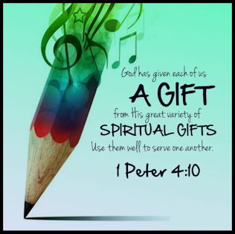

Crescentville United Methodist Church
A Changing Church for Changing Times
Pastor Rev. Lori Reyes
400 Sentner Street
Philadelphia, Pennsylvania 19120
215-745-7115
E-Mail: crescentvilleumc@gmail.com
Web Site: https://www.crescentvilleumc.com/
Facebook: https://www.facebook.com/crescentvilleumc
YouTube Channel:
https://www.youtube.com/@crescentvilleunitedmethodi7688

"Growing in Gratitude, Growing in Generosity"

September Stewardship Month*

Throughout September, we will reflect on what it means to be faithful stewards
of all God has entrusted to us. Stewardship is more than financial giving,
it is how we use our time, talents, gifts, and resources
to serve God and one another with grateful and generous hearts.

*Join us each Sunday as we grow together
in gratitude, generosity, and faithful living!

Crescentville United Methodist Church

18th Sunday after Pentecost Stewardship Series Week 4 Sept 27, 2026

Prelude
PLEASE STAND AS WE BEGIN OUR TIME OF WORSHIP – “Sweet, Sweet Spirit”

Please be seated
Welcome & Announcements

Birthday Recognitions for October

06 Lizzie Balaguer 11 Ma-Jennah Jean 27 Rose Obwot
07 Allyson Jenkins 17 Jean-Jacques Jean 29 Kimberly Grivas (Farrer)
08 Mary Meyer 18 Valerie Hobson 29 Peter Hanson
09 Damon Cunningham 22 Lea Cunningham

Is there anyone else celebrating a birthday in October?

BIRTHDAY RESPONSIVE READING

Celebrants: We thank God for the gift of life.

People: We thank God for you whose birthdays we celebrate this October!

Celebrants: Life is precious.

People: We are grateful for all of you. May God bless you in this time and throughout all your days.

All: We are glad that God has brought us together in this world. We are enriched by those who come into our lives, our families, our church, and our community. May we always be open to seeing God in others. May we always follow God’s leading into the future.

Celebrants: Thanks be To God for the gift of life.

People: Thanks be to God for the gift of life. Amen.

Please stand

Chorus of Welcome “The Family of God” - Pastor Lori 1st Sun 2025-07-06
I’m so glad I’m a part of the family of God—I’ve been washed in the fountain, cleansed by His blood! Joint heirs with Jesus as we travel this sod; for I’m part of the family, the family of God.

Call to Worship
Leader: God has blessed each of us with gifts to share.
People: Together, we offer our gifts to God.
Leader: Through our giving, serving, and loving, God is at work.
People: Together, we help build God’s kingdom.
All: Let us worship God with grateful and generous hearts!

Opening Worship Song “Build Your Kingdom Here” by Rend Collective

Come set Your rule and reign in our hearts again
Increase in us we pray; Unveil why we're made
Come set our hearts ablaze with hope like wildfire in our very souls
Holy Spirit come invade us now
-
We are Your church - We need Your pow'r in us
-
We seek Your kingdom first; We hunger and we thirst
Refuse to waste our lives; For You're our joy and prize
To see the captives' hearts released; The hurt the sick the poor at peace
We lay down our lives for heaven's cause
-
We are Your church - We pray revive this earth

Refrain : Build Your kingdom here; Let the darkness fear
Show Your mighty hand; Heal our streets and land
Set Your church on fire; Win this nation back
Change the atmosphere;Build Your kingdom here we pray

Unleash Your kingdom's pow'r; Reaching the near and far
No force of hell can stop Your beauty changing hearts
You made us for much more than this
Awake the kingdom seed in us; Fill us with the strength
and love of Christ
-

We are Your church - We are the hope on earth [Refrain]

Opening Prayer (in unison)

Gracious God, thank You for the gifts You have placed in each of us. Teach us to use our time, talents, and treasures to serve others and build Your kingdom. Unite us in love and use our lives for Your glory. In Jesus’ name, Amen.

Please be seated
Youth Message

Joys/Concerns – Gathered Prayer

Singing of the Lord’s Prayer - Our Father, which art in heaven, hallowed be Thy name; Thy kingdom come, Thy will be done, on earth as it is in heaven. Give us this day our daily bread; and forgive us our debts as we forgive our debtors. And lead us not into temptation but deliver us from evil. For Thine is the kingdom, and the power, and the glory, forever. Amen

Please be seated
Gifts and offerings
Offertory “Make Me A Blessing” “Please join in singing!
Please stand
The Doxology “Praise God, From Whom All Blessings Flow” # 94
Praise God, from whom all blessings flow; praise God, all creatures here below: Alleluia! Alleluia!
Praise God, the source of all our gifts! Praise Jesus Christ, whose power uplifts!
Praise the Spirit, Holy Spirit! Alleluia! Alleluia! Alleluia!
Offertory Prayer

Please Stand
Hymn of Reflection “I Come With Joy To Meet My Lord” tune: Land Of Rest

I come with joy to meet my Lord, forgiven, loved, and free;
in awe and wonder to recall His life laid down for me.

I come with Christians far and near to find, as all are fed,
the new community of love in Christ's communion bread.

As Christ breaks bread and bids us share, each proud division ends;
the love that made us, makes us one, and strangers now are friends.

And thus with joy we meet our Lord; his presence, always near,
is in such friendship better known: we see and praise Him here.

Together met, together bound, we'll go our different ways;
and as his people in the world, we'll live and speak His praise.

Please Be Seated
Gospel Lesson Acts 2:42-47 Pew Bible page # 1057
Sermon “Our Gifts Build God’s Kingdom”

Please stand
*Affirmation of Faith The Apostles’ Creed
I believe in God the Father Almighty, maker of heaven and earth;
And in Jesus Christ His only Son our Lord:
who was conceived by the Holy Spirit, born of the Virgin Mary,
suffered under Pontius Pilate, was crucified, dead, and buried;
the third day He rose from the dead; He ascended into heaven,
and sitteth at the right hand of God the Father Almighty;
from thence He shall come to judge the quick and the dead;

I believe in the Holy Spirit, the holy catholic church,
the communion of saints, the forgiveness of sins,
the resurrection of the body, and the life everlasting. Amen.

Closing Hymn “Filled with the Spirit’s Power” tune: Morecambre

Filled with the Spirit’s power, with one accord the infant church confessed its risen Lord.
O Holy Spirit, in the church today no less Your power of fellowship display.

Now with the mind of Christ set us on fire, that unity may be our great desire.
Give joy and peace; give faith to hear Your call, and readiness in each to work for all.

Widen our love, good Spirit to embrace in Your strong care all those of every race.
Like wind and fire with life among us move, till we are known as Christ’s and Christians prove.

Benediction

Choral Benediction “Sent Forth by God’s Blessing” vs 2 # 664

With praise and thanksgiving to God ever living,
the tasks of our everyday life we will face.
Our faith ever sharing, in love ever caring,
embracing God’s children of each tribe and race.
With Your grace You feed us, with Your light now lead us;
unite us as one in this life that we share.
Then may all the living with praise and thanksgiving
Give honor to Christ and that name which we bear.

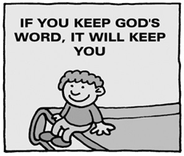
Lectionary Scripture Readings
The Bible isn't just there to read. It's a book full of all kinds of advice. From relationships to money to how to get along with your parents, it's all in there. When we become wiser, we make much better decisions, and with good decisions comes many other good things.
October 04, 2026 - 19th Sunday after Pentecost
Matthew 21:33-46 - Exodus 20:1-4, 7-9, 12-20 and Psalm 19 -
Isaiah 5:1-7 and Psalm 80:7-15 - Philippians 3:4b-14

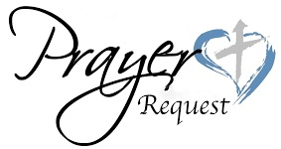
Joys & Concerns: Keep those prayers going and thank God for His answers! To add a prayer request or share a joy,
please call or text Sue Creevey 267-847-6029
Our prayers display trust in God, our belief in Christ, and when prayers are answered, we praise Him for his faithfulness. Our prayers glorify God. Praying is not just a conversation. Prayer is praise for the work God will do through our prayers. He has delivered us from such a deadly peril, and he will deliver us again.

Prayer Requests from September 20th
Traveling mercies for David & Heather Wilson as they cruise in Europe.
JOY - Jean Bernard is grateful for all God has done for him.
Continued prayers for healing for Keri Sanders
Prayers of healing for Lee & John Waldner
Healing prayers for Katie & John Brett
Healing prayers for Bradyn Kelly (Snyder’s grandson) he tore his ACL at football practice.
Gerry Rozanski fell at a wedding on Sept 19th and broke her hip. Surgery was on Sept 20th.

Continuing Prayers for:
Martha & Wondor Korto Sheryl Duke David & Esther Clinton Amber Sarkar Tracey & Bill Lewis Pastor Lori Lori Rovevelli Robert Smith Walter Rininsland (Joan Pott's Dad) Crescentville UMC
Kass Greenlaw Michael Groves
Prayers for those living with constant pain and other ailments.
For those who are sick, and those that grieve. For those who live in war zones and poverty.
For families, especially:
Zilpha and James Browne, The Stefanescu, Mc Manus, Salvadore, and Didirea Families, Jean Bernard and family, The Spotts Family, Bresnan Family
For an end to violence, for peace and stability
Philadelphia, especially our community - Sierra Leone, Africa
Haiti - Israel and Hamas - Ukraine and Russia
Please praise and pray for our youth – they are the future of our church!

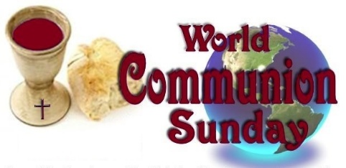
NEXT SUNDAY OCTOBER 4TH
IS WORLD COMMUNION SUNDAY
Our second collection will be to support the World Communion Sunday Special Sunday fund. Half of the proceeds provide World Communion Sunday Scholars grants administered by the General Board of Global Ministries, while the remaining half funds the Ethnic Scholarship Program and Ethnic In-Service Training program for racial and ethnic-minority students

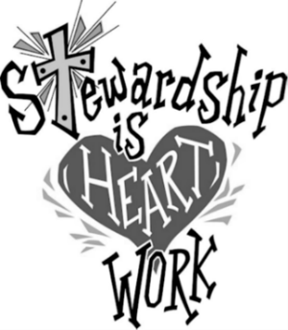
YOUTH RAISE THE ROOF CAMPAIGN
Our youth have coin cards to give you for donations for the new roof. Please ask a youth or Pastor for a card. This campaign extends until October 25th. Thank you!

