Transfiguration Sunday Pretzel Sunday February 23, 2020

Announcements

PLEASE, sign and pass the blue attendance pads that are in every row

*Chorus of Welcome “The Family of God”
I’m so glad I’m a part of the family of God—I’ve been washed in the fountain,
cleansed by His blood! Joint heirs with Jesus as we travel this sod;
for I’m part of the family, the family of God.

*Call to Worship Psalm 99
L: The Lord is King, and the people tremble.
P: God sits on His throne above the winged creatures, and the earth shakes.
L: The Lord is mighty in Zion; God is supreme over all the nations.
P: Everyone will praise God’s great and majestic name. Holy is He!

*Opening Hymn “When Morning Gilds the Skies” # 185

*Opening Prayer
Almighty and Holy God, whose Son was revealed in majesty
before He suffered death upon the cross: give us grace to know His glory,
that we may be strengthened to suffer with Him and be changed
into His likeness, from glory to glory; who is alive and reigns with You,
in the unity of the Holy Spirit, one God, now and for ever. Amen.

Children’s Message

Birthday Recognition

Joys & Concerns
Gathered Prayer
The Lord’s Prayer (Please use “debts” and “debtors”) # 896

Gifts and Offertory

The Offertory “Awakening Chorus” # 66

*The Doxology “Praise God, from Whom All Blessings Flow” # 95

*The Offertory Prayer

*Hymn “Love Divine, All Loves Excelling” [VS. 1-3] # 384

(Children are dismissed to the Nursery and Library)

Gospel Lesson St. Matthew 17:1-9 # 951

Sermon “Get Up”

*Affirmation of Faith The Apostles’ Creed # 881

*Hymn “O Come and Dwell in Me” # 388

Benediction
Quiet Meditation, Reflection, and Prayer

*Choral Benediction “Love Divine, All Loves Excelling” [VS. 4] # 384

Finish, then, Thy new creation; pure and spotless let us be.
Let us see Thy great salvation perfectly restored in Thee;
changed from glory into glory, till in heaven we take our place,
till we cast our crowns before Thee, lost in wonder, love and praise.

*Please stand if you are able

Did I just say pretzels?

Yes, pretzels are a Lenten tradition in Christianity dating back to the early 600s. The first pretzel was an invention of an Italian monk who was looking for a simple reminder to his brother monks that Lent is a time for prayer. So, fashioning a Lenten bread with only flour, water and salt (in those days people cooked without butter or oil during Lent), he rolled out the dough in strips. Then he gave the world the distinctive pretzel shape by folding the strip of dough over itself, just as one would cross one's arms over the heart in a gesture of prayer. The bread was then baked as a soft bread, just like the big soft pretzels we have today.

In the shape of crossed arms, these little breads were called bracellae, the Latin word for "little arms."
From this word came the German word bretzel, the root of our familiar word pretzel.

Today, we have pretzels as a reminder of the importance of prayer, of daily turning to our Lord this Lent so that we better prepare for the great events of Holy Week and the Easter celebration. Each pretzel is a delicious Lenten treat to remind us to turn to the Lord often and "taste and see that the Lord is good" (Psalm 34:8).

Lord, may these pretzel snacks remind us to always turn to you in prayer.

Lectionary Lessons for Next Sunday:
Genesis 2:15-17, 3:1-7, Psalm 32, Romans 5:12-19, & Matthew 4:1-11
2020 Flower Chart in the Narthex Cost is $25 for 2 bouquets, $20 for a centerpiece.

WELCOME TO ALL OUR VISITING FRIENDS!
It is a pleasure to have you with us today, and it will be an even greater pleasure to see you again! We hope that your faith will be strengthened by your time here. It is a genuine privilege to gather as God’s people to open ourselves to the presence of God and to praise God with living hearts. Large print hymnbooks and bulletins are available.
CRESCENTVILLE UMC MISSION STATEMENT
We at Crescentville United Methodist Church believe that Jesus Christ is our Lord and Savior and we will invite people into a relationship with Christ. Empowered by the Holy Spirit, we will continue to grow spiritually in our relationship with Christ. As a fellowship of caring, concerned people, we will respond as disciples to reach out and serve the community.

Weekly Offering: Sunday 2/16/20 $1,180.00. Your offerings are needed and appreciated. Thank you!

CIRCLE OF CONCERN
Week 1: Farol Jennings; Daugherty family; bus drivers.
Week 2: Mallory; Gene Saloky; Pat Milner & family; Jeff; Sutton family; Nathan, Emily & Petra.
Week 3: Marie Connelly; Rush Limbaugh; Stephen Matthias; little Maurice; Wadiya; Arnhold family.
Week 4: William Schule, cured from cancer; Mary & Scott Meyers; Pop Francis; Mary; Joseph Korto; My families in Haiti; Sana & Joshua, future family, health & finance; Pray for my children; Godfred Yeboah.
Continuing Prayers: Pastor Randy & family; Dorothy Buzzard; June Christopher; Fred Frank; Rev. Khan; Betty Sauerwald; all our family & friends of CUMC & FMUMC; Lawncrest Community.

Thank You Jesus for Answered Prayers!

Family & Friends Serving in the Armed Services: Pray for President Trump,
our Men & Women serving here and abroad, our nation and for world peace.

CALENDAR OF EVENTS
Today, Sun., Feb. 23 – Sunday Worship Sevice 10:30 AM. Pretzel Sunday!
Wed., Feb. 26 – 7 PM Ash Wednesday Service here at Crescentville.
Sun., March 1 – Sunday Worship Sevice 10:30 AM.
Wed., March 4 – Lenten Vespers 7 PM at PPH.
Sun., March 8 – Sunday Worship Sevice 10:30 AM.
Wed., March 11 – Lenten Vespers 7 PM at PPH.
Sun., March 15 – Sunday Worship Sevice 10:30 AM.
Wed., March 18 – Lenten Vespers 7 PM at PPH.
Sun., March 22 – Sunday Worship Sevice 10:30 AM.

Wed., March 25 – Lenten Vespers 7 PM at PPH.
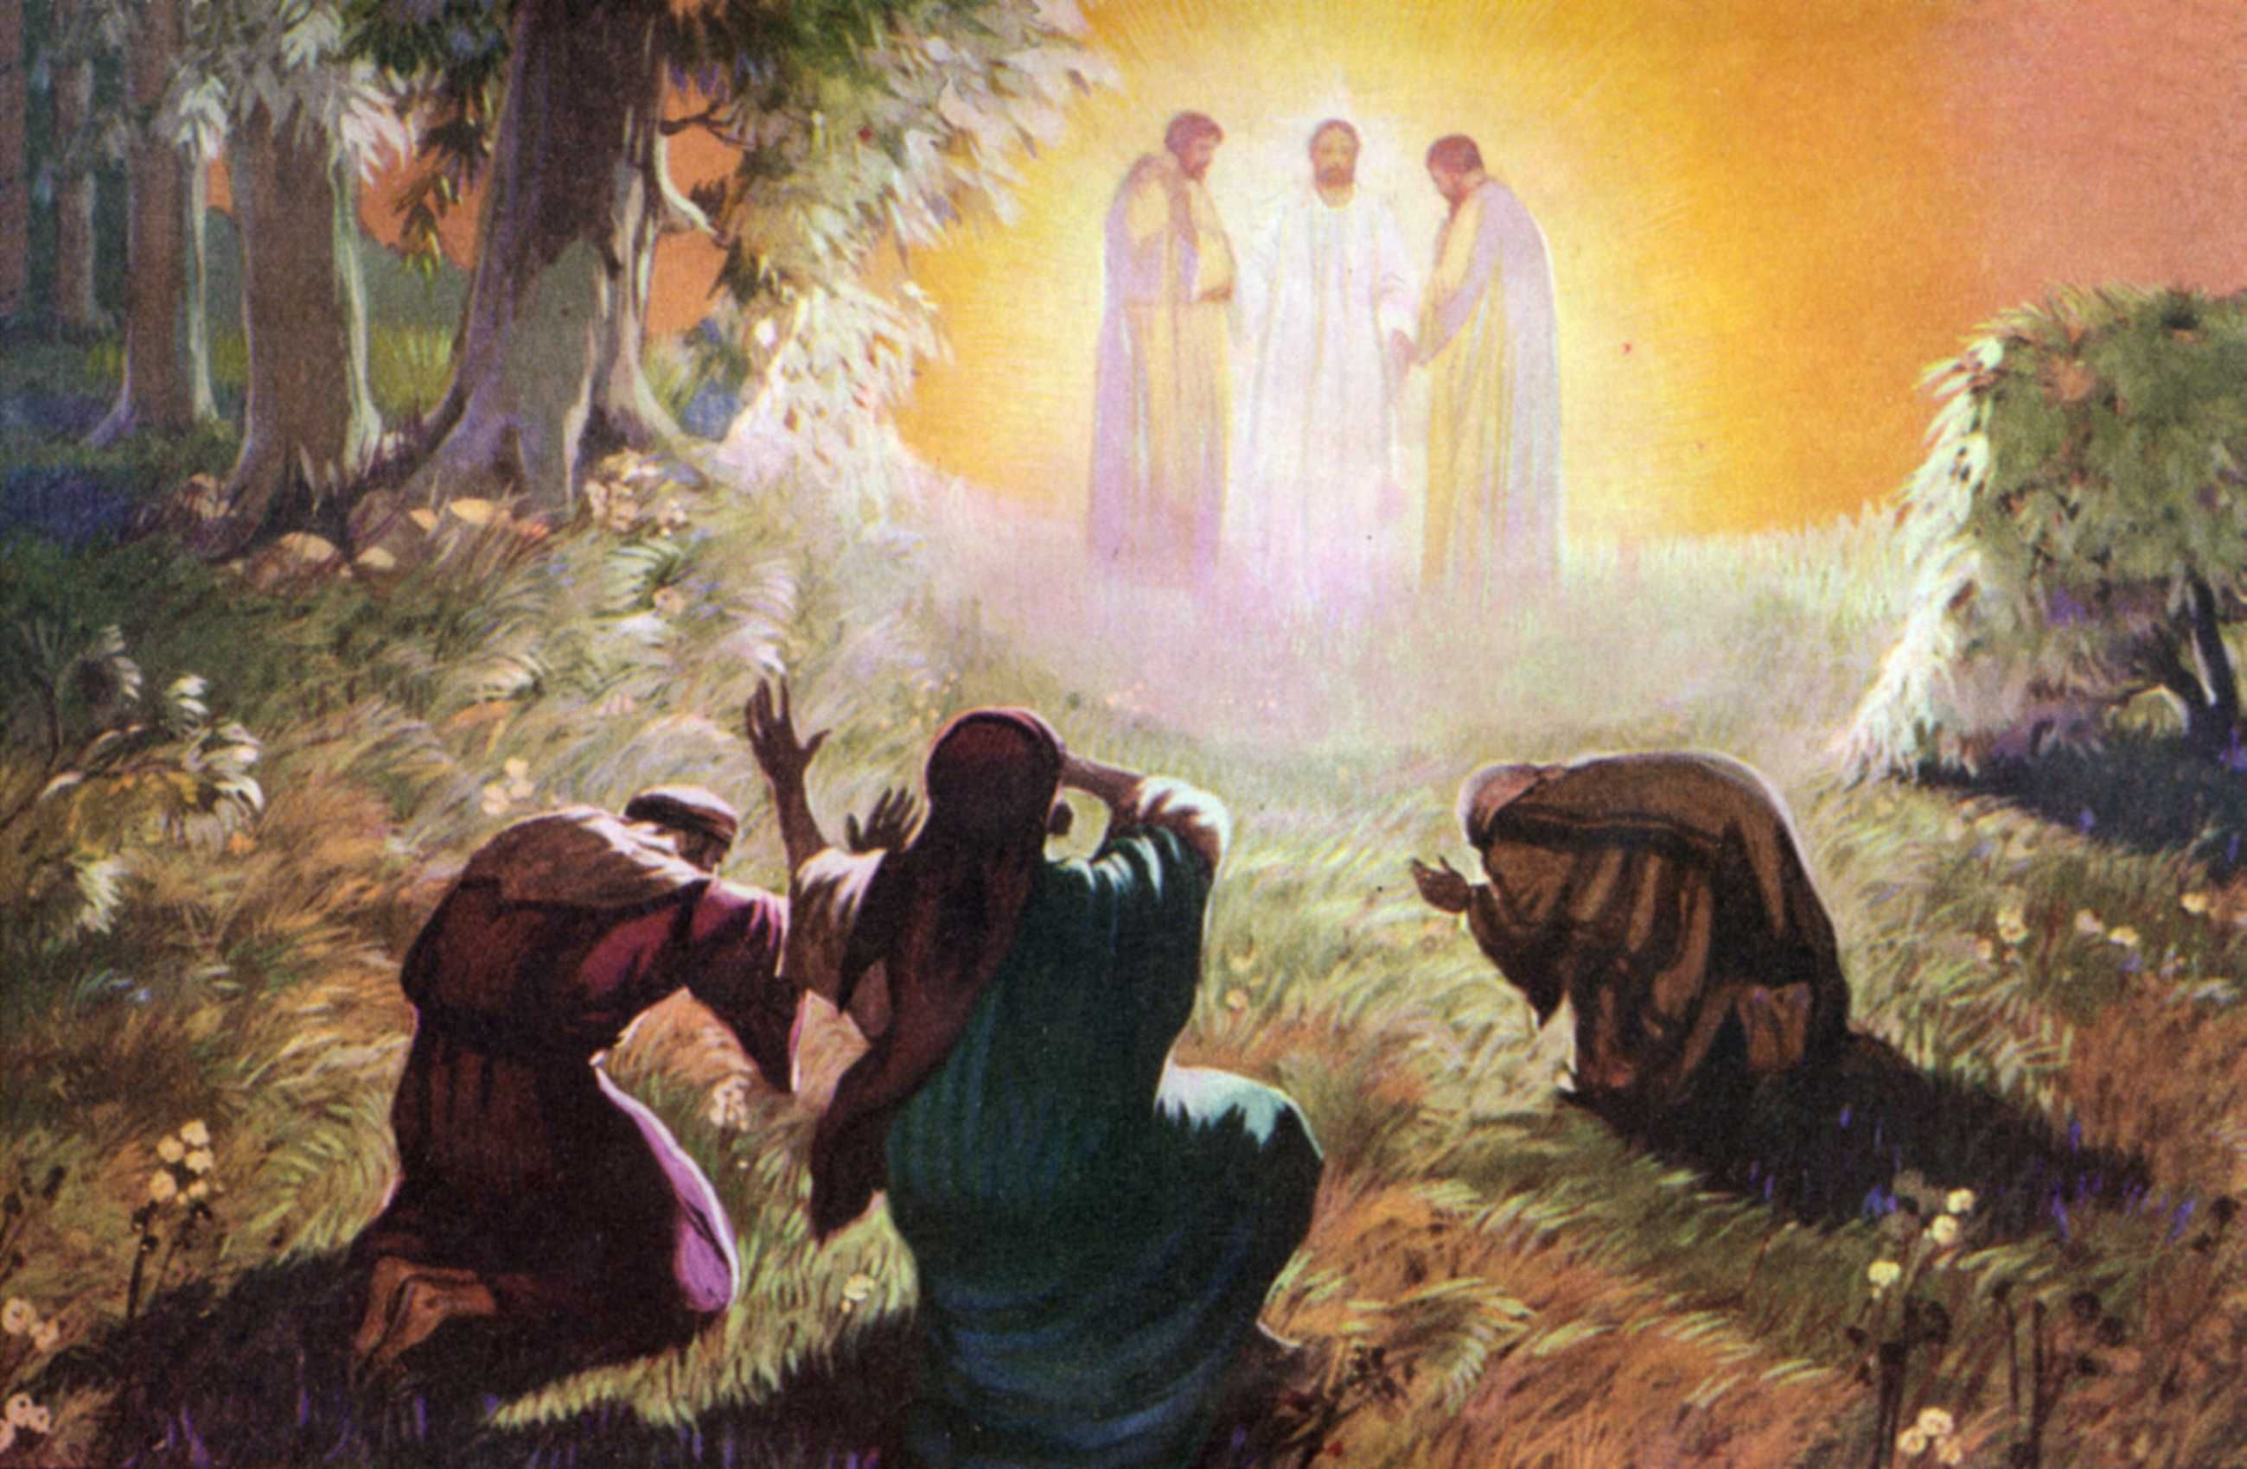

Crescentville United Methodist Church
A Changing Church for Changing Times
Rev. Randy M. Brubaker, Pastor
412 Sentner Street
Philadelphia, Pennsylvania 19120
215-745-7115 – Fax. 215-745-7258
crescentvilleumc@gmail.com
Web Site – crescentvilleumc.com

March Birthdays

3 Kass Greenlaw 15 Dende Korpoi
4 Tammy Murtha 20 Erin Snyder Kelly
6 Suzanne Turner Kathleen McAdoo
8 Abdulai Jah Edith Uhlman
Bill Barry Andrew Kamara
12 Marina Macauley Coker 24 Linda Pultro
13 Dot Gallagher 30 Hank Baumgartel
Ludwig McEachnie

Is there anyone else celebrating a birthday in March?

Celebrants: We thank God for the gift of life.

People: We thank God for you whose birthdays we celebrate this March!

Celebrants: Life is precious.

People: We are grateful for all of you. May God bless you in this time and
throughout all your days.

All: We are glad that God has brought us together in this world. We are
enriched by those who come into our lives, our families, our church,
and our community. May we always be open to seeing God in others.
May we always follow God’s leading into the future.

Celebrants: Thanks be To God for the gift of life.

People: Thanks be to God for the gift of life. Amen.

