January 25, 2026
3rd SUNDAY AFTER THE EPIPHANY
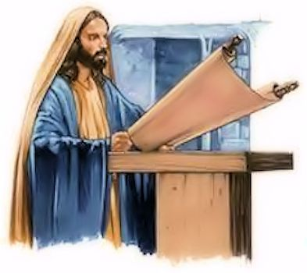

Crescentville United Methodist Church
A Changing Church for Changing Times
Pastor Rev. Lori Reyes
400 Sentner Street
Philadelphia, Pennsylvania 19120
215-745-7115
E-Mail: crescentvilleumc@gmail.com
Web Site: https://www.crescentvilleumc.com/
Facebook: https://www.facebook.com/crescentvilleumc
YouTube Channel:
https://www.youtube.com/@crescentvilleunitedmethodi7688

Crescentville United Methodist Church

Third Sunday after the Epiphany January 25, 2026

Prelude
PLEASE STAND AS WE BEGIN OUR TIME OF WORSHIP – “Christ Be Our Light”
Welcome & Announcements

Chorus of Welcome “The Family of God”
I’m so glad I’m a part of the family of God—I’ve been washed in the fountain, cleansed by His blood!
Joint heirs with Jesus as we travel this sod; for I’m part of the family, the family of God.

Call to Worship
L: The Spirit of God is upon us.
P: We are called to be God's people.
L: The Spirit of God is upon us.
P: We are called to be the body of Christ.
L: Come let us worship God,
P: Who binds us together in love and service.
Opening Worship Praise Song “You Say” by Lauren Daigle

I keep fighting voices in my mind that say I'm not enough
Every single lie that tells me I will never measure up
Am I more than just the sum of every high and every low?
Remind me once again just who I am because I need to know

Refrain: Ooh-oh - You say I am loved when I can't feel a thing
You say I am strong when I think I am weak
And you say I am held when I am falling short
And when I don't belong, oh, You say I am Yours
And I believe oh, I believe - What You say of me - I believe

The only thing that matters now is everything You think of me
In You, I find my worth, in You, I find my identity

REFRAIN 2X

Oh, I believe - Yes, I believe - What You say of me - I believe

Opening Prayer (in unison)
Bountiful God, you have blessed us with so many gifts. In this time of worship, may we be open to receiving these gifts. Help us claim our gifts and use them to bring liberation and justice to a hurting world. May the words of our mouths, and the meditations of our hearts, be acceptable to you. May the transforming Spirit of joy and unity bind us together as your body, that we may be your hands and feet and voice in this, your world. Amen.

Please be seated
Youth Message

Joys/Concerns- The People’s Prayer – The Lord’s Prayer

Singing of the Lord’s Prayer - Our Father, which art in heaven, hallowed be Thy name; Thy kingdom come, Thy will be done, on earth as it is in heaven. Give us this day our daily bread; and forgive us our debts as we forgive our debtors. And lead us not into temptation but deliver us from evil. For Thine is the kingdom, and the power, and the glory, forever. Amen

Receiving God’s Gifts and Offerings

Offertory “Waymaker” Please join in singing!
Please stand
The Doxology “Praise God, From Whom All Blessings Flow” # 95

Praise God, from whom all blessings flow; praise God, all creatures here below;
praise God above, ye heavenly host; praise Father, Son, and Holy Ghost. Amen.

The Offertory Prayer

Hymn of Reflection Come Ye Sinners, Poor and Needy # 340

Come, ye sinners, poor and needy, Weak and wounded, sick and sore;
Jesus ready stands to save you, Full of pity, love and power.

Refrain:
I will arise and go to Jesus, He will embrace me in His arms;
In the arms of my dear Savior, Oh, there are ten thousand charms.

Come, ye thirsty, come, and welcome, God’s free bounty glorify;
True belief and true repentance, Every grace that brings you nigh. [refrain]

Come, ye weary, heavy-laden, Lost and ruined by the fall;
If you tarry till you’re better, You will never come at all. [refrain]

Let not conscience make you linger, Nor of fitness fondly dream;
All the fitness He requireth Is to feel your need of Him. [refrain]

Please Be Seated
Gospel Lesson Luke 4:14-21 [NRSV]
¹⁴ Then Jesus, in the power of the Spirit, returned to Galilee, and a report about him spread through all the surrounding region. ¹⁵ He began to teach in their synagogues and was praised by everyone. ¹⁶ When he came to Nazareth, where he had been brought up, he went to the synagogue on the Sabbath day, as was his custom. He stood up to read, ¹⁷ and the scroll of the prophet Isaiah was given to him. He unrolled the scroll and found the place where it was written: ¹⁸ “The Spirit of the Lord is upon me, because he has anointed me to bring good news to the poor. He has sent me to proclaim release to the captives and recovery of sight to the blind, to set free those who are oppressed, ¹⁹ to proclaim the year of the Lord’s favor.” ²⁰ And he rolled up the scroll, gave it back to the attendant, and sat down. The eyes of all in the synagogue were fixed on him. ²¹ Then he began to say to them, “Today this scripture has been fulfilled in your hearing.”

Sermon "To Preach and To Heal”

Please stand
Affirmation of Faith The Apostles’ Creed
I believe in God the Father Almighty, maker of heaven and earth;
And in Jesus Christ His only Son our Lord:
who was conceived by the Holy Spirit, born of the Virgin Mary,
suffered under Pontius Pilate, was crucified, dead, and buried;
the third day He rose from the dead; He ascended into heaven,
and sitteth at the right hand of God the Father Almighty;
from thence He shall come to judge the quick and the dead;

I believe in the Holy Spirit, the holy catholic church,
the communion of saints, the forgiveness of sins,
the resurrection of the body, and the life everlasting. Amen.

Closing Hymn “Open My Eyes, That I May See” # 454

Open my eyes, that I may see glimpses of truth thou hast for me; place in my hands
the wonderful key that shall unclasp and set me free. Silently now I wait for thee,
ready, my God, thy will to see. Open my eyes, illumine me, Spirit divine!

Open my ears, that I may hear voices of truth thou sendest clear; and while the wavenotes
fall on my ear, everything false will disappear. Silently now I wait for thee,
ready, my God, thy will to see. Open my ears, illumine me, Spirit divine!

Open my mind, that I may read More of thy love in word and deed;
What shall I fear while yet Thou dost lead? Only for light from thee I plead.
Silently now, I wait for thee, ready, my God, thy will to see.
Open my mind, illumine me, Spirit divine!

Open my mouth, and let me bear gladly the warm truth everywhere; open my heart
and let me prepare love with thy children thus to share. Silently now I wait for thee,
ready, my God, thy will to see. Open my heart, illumine me, Spirit divine!
Open my heart, illumine me, Spirit divine!

Benediction

Choral Benediction “You Say” [refrain only]

Ooh-oh - You say I am loved when I can't feel a thing
You say I am strong when I think I am weak
You say I am held when I am falling short
When I don't belong, oh, You say I am Yours
And I believe, oh, I believe - What You say of me - I believe
Oh, I believe - Yes, I believe - What You say of me - I believe

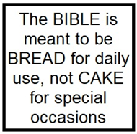
Lectionary Scripture Readings
Wisdom is gained from God’s Word. The Proverbs especially talk about the importance of seeking after wisdom, God’s wisdom.
February 01, 2026 - Fourth Sunday after the Epiphany
Matthew 5:1-12 - Micah 6:1-8 - Psalm 15 - 1 Corinthians 1:18-31


Joys & Concerns: Keep those prayers going and thank God for His answers! To add a prayer request or share a joy,
please call or text Sue Creevey 267-847-6029.
When someone knows you’ve been praying for him/her, that person will really be happy about your care for him/her. It will boost their happiness and make some physiological changes in their brain. This is because knowing that someone is praying for you will heighten your sense of well-being and will help you feel loved by someone who’s very special in your life. Especially if going through hard times, knowing that someone is there for us, will keep us feeling better and stronger.

Prayer Requests from January 18th
Prayers for the Cole and Blibo families. The memorial service of the late Fatu C Blibo will be held on January 31st, 10:00 AM, at the Exdous Funeral Home 1001 N. 63rd Street, Phila PA 19151
Prayers for those not able to be with us in worship today.
Amber Sakar is now in Temple Hospital where she will have a 3rd surgery on her back. Prayers that surgery goes well and recovery is successful.
Prayers for Cocoa's dog Diesel as he has dental surgery for an abscess.
Traveling mercies for Sonja Browne as she goes on vacation.
Continued prayers for Kathy Saloky as her leg is healing, but her back is bothering her.
Prayers for Lori Rovevelli (Gene Saloky sister) she is in the hospital for tests to determine cause of her chest pains.
Abdulai asks for prayers for his children.
Continuing Prayers for:
Martha & Wondor Korto Scott Meyer Sheryl Duke David & Esther Clinton
Tracey & Bill Lewis Jennifer Pastor Lori Amber Sarkar

For families, especially:
Zilpha and James Browne, The Stefanescu, Mc Manus, Salvadore, and Didirea Families, Jean Bernard and family, The Spotts Family, Bresnan Family

For an end to violence, for peace and stability
Philadelphia, especially our community - Sierra Leone, Africa
Haiti - Israel and Hamas - Ukraine and Russia

Please praise and pray for our youth – they are the future of our church!

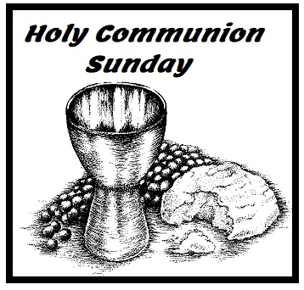
Sunday, February 1st
Holy Communion
A second collection will be taken for the
Pastor’s Discretionary Fund.

