October 25, 2026
22nd Sunday After Pentecost
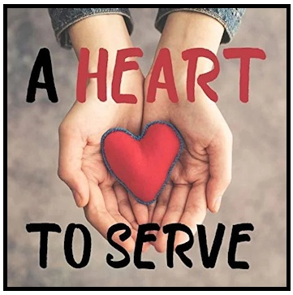
Crescentville United Methodist Church
A Changing Church for Changing Times
Pastor Rev. Lori Reyes
400 Sentner Street
Philadelphia, Pennsylvania 19120
215-745-7115
E-Mail: crescentvilleumc@gmail.com
Web Site: https://www.crescentvilleumc.com/
Facebook: https://www.facebook.com/crescentvilleumc
YouTube Channel:
https://www.youtube.com/@crescentvilleunitedmethodi7688

Crescentville United Methodist Church

22nd Sunday after Pentecost October 25, 2026

Prelude
PLEASE STAND AS WE BEGIN OUR TIME OF WORSHIP – “Sweet, Sweet Spirit”

Please be seated
Welcome & Announcements

Birthday Recognitions for November

02 Janet Jeitner 02 Darryl Sutton 12 Luoli Kulah
18 Allison Gaston (Meyer) 18 Linda Sutton 19 Scott Meyer
24 Jim Creevey 26 Reonna Browne 26 Naiima Jabati

Is there anyone else celebrating a birthday in November?

BIRTHDAY RESPONSIVE READING

Celebrants: We thank God for the gift of life.

People: We thank God for you whose birthdays we celebrate this November!

Celebrants: Life is precious.

People: We are grateful for all of you. May God bless you in this time and throughout all your days.

All: We are glad that God has brought us together in this world. We are enriched by those who come into our lives, our families, our church, and our community. May we always be open to seeing God in others. May we always follow God’s leading into the future.

Celebrants: Thanks be To God for the gift of life.

People: Thanks be to God for the gift of life. Amen.

Please stand

Chorus of Welcome “The Family of God” - Music & Drama Camp 2009 Survivor Babylon
I’m so glad I’m a part of the family of God—I’ve been washed in the fountain, cleansed by His blood!
Joint heirs with Jesus as we travel this sod; for I’m part of the family, the family of God.

Call to Worship
Leader: We gather today to worship the God who calls us to serve with love.
People: We come with open hearts, ready to follow Christ.
Leader: God calls us to live with humility, kindness, and compassion.
People: May our words and actions reflect God's love.
Leader: Come, let us worship the Lord!
All: With joyful hearts, we praise God's holy name!

Opening Worship Song “With Every Act of Love” by Jason Gray

Sitting at the stoplight he can’t be bothered by the heart cry
Written on the cardboard in her hands
Oh but when she looks him in the eyeHis heart is broken open wide
and he feels the hand of God reach out through him.
As Heaven touches earth

Refrain:
Oh–oh–oh–oh-oh-oh we bring the Kingdom come
Oh–oh–oh–oh-oh-oh with every act of love
Jesus help us carry You alive in us, Your light shines through
With every act of love we bring the Kingdom come

There’s silence at the table he wants to talk but he’s not able
For all the shame that’s locked him deep inside
Oh but her words are the medicine when she says they can begin again
And forgiveness will set him free tonight
As Heaven touches earth (Refrain)

God put a million, million doors in the world
For his love to walk through One of those doors is you
I said, God put a million, million doors in the world
For his love to walk through One of those doors is you (Refrain 2x)

Opening Prayer (in unison)

Gracious and loving God, Thank You for bringing us together in worship today. Open our hearts to Your Word and remind us that true service begins with love. Teach us to lead with humility, speak with kindness, and care for one another with compassion. May everything we do bring glory to Your name, In Jesus name, we pray. Amen.

Please be seated
Youth Message

Joys/Concerns – Gathered Prayer

Singing of the Lord’s Prayer - Our Father, which art in heaven, hallowed be Thy name; Thy kingdom come, Thy will be done, on earth as it is in heaven. Give us this day our daily bread; and forgive us our debts as we forgive our debtors. And lead us not into temptation but deliver us from evil. For Thine is the kingdom, and the power, and the glory, forever. Amen

Please be seated
Gifts and offerings
A second offering will be collected for our youth’s
"Raise the Roof Campaign".
You are welcome to donate at this time, no card needed.
Thank you for your support of our youth in this fundraiser.

Offertory “We Are His Hands” - “Raise The Roof”, “Please join in singing!

Please stand
The Doxology “Praise God, From Whom All Blessings Flow” # 94
Praise God, from whom all blessings flow; praise God, all creatures here below: Alleluia! Alleluia!
Praise God, the source of all our gifts! Praise Jesus Christ, whose power uplifts!
Praise the Spirit, Holy Spirit! Alleluia! Alleluia! Alleluia!
Offertory Prayer

Please Stand
Hymn of Reflection “Lord, Speak to Me” Vs 1,2,3,4 # 463

Lord, speak to me, that I may speak in living echoes of Thy tone;
As Thou hast sought, so let me seek Thine erring children lost and lone.
--
O strengthen me, that while I stand firm on the rock, and strong in Thee,
I may stretch out a loving hand to wrestlers with the troubled sea.
--
O teach me, Lord, that I may teach the precious things Thou dost impart;
And wing my words, that they may reach the hidden depths of many a heart.
--
O fill me with Thy fullness, Lord, until my very heart o'erflow
In kindling thought and glowing word, Thy love to tell, Thy praise to show.

Please Be Seated
Gospel Lesson 1 Thessalonians 2:1-8 Pew Bible page # 1146

Sermon “Serving with a Heart of Love”

Please stand
*Affirmation of Faith The Apostles’ Creed
I believe in God the Father Almighty, maker of heaven and earth;
And in Jesus Christ His only Son our Lord:
who was conceived by the Holy Spirit, born of the Virgin Mary,
suffered under Pontius Pilate, was crucified, dead, and buried;
the third day He rose from the dead; He ascended into heaven,
and sitteth at the right hand of God the Father Almighty;
from thence He shall come to judge the quick and the dead;

I believe in the Holy Spirit, the holy catholic church,
the communion of saints, the forgiveness of sins,
the resurrection of the body, and the life everlasting. Amen.

Closing Hymn “Pass It On” # 572

It only takes a spark to get a fire going
And soon all those around, can warm up in glowing
That’s how it is with God’s love
Once you’ve experienced it, you spread His love to everyone
You want to pass it on

What wondrous time is spring, when all the trees are budding
The birds begin to sing, the flowers start their blooming
That’s how it is with God’s love
Once you’ve experienced it, you want to sing
“It’s fresh like spring”; you want to pass it on

I wish for you my friend, this happiness that I’ve found
You can depend on Him, it matters not where you’re bound
I’ll shout it from the mountain top – PRAISE GOD
I want the world to know; the Lord of love has come to me
I want to pass it on

Benediction

Choral Benediction “Lord, Speak to Me” Vs 5 # 463

O use me, Lord, use even me, just as You will, and when, and where,
until your blessed face I see, Your rest, Your joy, Your glory share


Lectionary Scripture Readings
We all need to face scary challenges in life. In these testing times, the Bible can give us the courage we need to see things through. Studying the word of God will give you the strength you need to face up to almost any adversity.
November 1, 2026 – All Saints Sunday
Matthew 5:1-12 - Revelation 7:9-17 and Psalm 34:1-10, 22 - 1 John 3:1-3

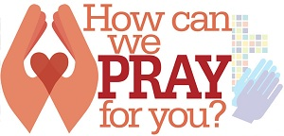
Joys & Concerns: Keep those prayers going and thank God for His answers! To add a prayer request or share a joy,
please call or text Sue Creevey 267-847-6029
When we pray for someone else it draws us closer in relationships. Praying for your spouse, child, or friend helps them to see how much you love them. Almost no one you meet will decline being prayed over. Offering to pray for someone is a free and powerful gift you can give to anyone you meet.

Prayer Requests from October 18th
Prayers for Henry Mishel who is having medical issues.
Traveling mercies for Paul Wilson, and prayers for people not in church today.
Prayers for Bradyn Kelly as he has surgery for ACL repair. Prayers for successful surgery and recovery.
Traveling mercies for the Sutton family as they travel to Maine to visit Marcus & Darryl.
Prayers for Gerry Rozanski to continue doing well in recovery.
Prayers for Gerry's stepdaughter Virginia Rozanski who will be having back surgery on Monday 10/19. Prayers for successful surgery and recovery.
Healing prayers for Keri Sanders, Lee & John Waldner, Pat, Stacy and Ryan Bresnan, Kristin and Greg Waldner.
Jean Bernard asks for prayers for his family.
Prayers for Michael Groves and his partner of many years, Debbie. Mike is in hospice and they have told us he will most likely be with us a few days to a week. Prayers for Mike & Debbie.
Kass Greenlaw is home with her son and doing well. Prayers for continued recovery.
Prayers for Carol Evans as she is having kidney issues.

Continuing Prayers for:
Martha & Wondor Korto Sheryl Duke David & Esther Clinton Amber Sarkar Tracey & Bill Lewis Pastor Lori Lori Rovevelli Robert Smith Walter Rininsland (Joan Pott's Dad) Crescentville UMC
Kass Greenlaw Michael Groves
Prayers for those living with constant pain and other ailments.
For those who are sick, and those that grieve. For those who live in war zones and poverty.
For families, especially:
Zilpha and James Browne, The Stefanescu, Mc Manus, Salvadore, and Didirea Families, Jean Bernard and family, The Spotts Family, Bresnan Family
For an end to violence, for peace and stability
Philadelphia, especially our community - Sierra Leone, Africa
Haiti - Israel and Hamas - Ukraine and Russia
Please praise and pray for our youth – they are the future of our church!

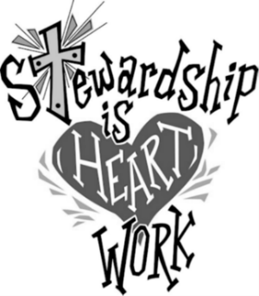
YOUTH "RAISE THE ROOF CAMPAIGN"
A second offering will be collected on Sunday October 25th
for our youth’s "Raise the Roof Campaign".
You are welcome to donate at this time, no card needed.
Thank you for your support of our youth in this fundraiser.

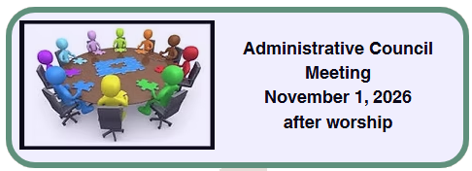
As this council meeting may go overtime, snacks will be provided,
and if you wish you may bring a light lunch.

