**March 5, 2023**

**2nd Sunday in Lent**

**Communion Sunday**

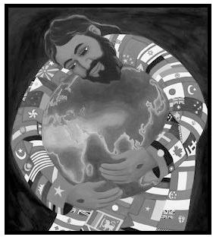

**Crescentville United Methodist Church**

**A Changing Church for Changing Times**

**Rev. Randy M. Brubaker, Pastor**

**412 Sentner Street**

**Philadelphia, Pennsylvania 19120**

**215-745-7115**

***E-Mail: crescentvilleumc@gmail.com***

**Web Site:** **https://www.crescentvilleumc.com/**

**Facebook:** **https://www.facebook.com/crescentvilleumc**

**YouTube Channel:**

[**https://www.youtube.com/@crescentvilleunitedmethodi7688**](https://www.youtube.com/@crescentvilleunitedmethodi7688)

*Today we hear the Psalmist talk about knowing that God, who made heaven and earth, it the One who helps us. Think about that for a moment; God helps us! And not only does God help us, but we can be aware of God’s helping us! God, indeed, loves the world; and because of that, God loves YOU! And you, like the Psalmist; and you, like Nicodemus, can know that God loves…because Jesus said so!*

*– Pastor Randy*

***Crescentville & Frankford Memorial United Methodist Churches***

***Second Sunday in Lent* March 5, 2023**

**Welcome**

Chorus of Welcome *“The Family of God”*

I’m so glad I’m a part of the family of God—I’ve been washed in the fountain, cleansed by His blood!

Joint heirs with Jesus as we travel this sod; for I’m part of the family, the family of God.

**\*Call to Worship** *Psalm 121*

*I look to the mountains; where will my help come from? My help will come from the Lord,*

*who made heaven and earth. He will not let you fall; your protector is always awake.*

*The protector of Israel never dozes or sleeps. The Lord will guard you; he is by your side to protect you.*

*The sun will not hurt you during the day, nor the moon during the night. The Lord will protect you*

*from all danger; he will keep you safe. He will protect you as you come and go now and forever.*

**\*Hymn of Repentance** *“My Faith Looks Up to Thee”* [VS. 1-2] # 452

My faith looks up to thee, thou Lamb of Calvary, Savior divine!  
Now hear me while I pray, take all my guilt away, O let me from this day be wholly thine!

May thy rich grace impart strength to my fainting heart, my zeal inspire!  
As thou hast died for me, O may my love to thee pure, warm, and changeless be, a living fire!

**Prayer of Confession** *(seated and bowed)*

**Almighty God, as we seek Your truth, we are confronted with the errors of our ways.**

**Grant to us, we pray, that as we confess our shortcomings to You, we may know the fullness**

**of Your grace and more deeply seek Your truth in and for our lives; through Jesus Christ,**

**who is alive and reigns with You, in the unity of the Holy Spirit, one God, now and for ever. Amen.**

*Silent Prayer and Meditation………………..Words of Forgiveness*

**Hymn of Grace** *“My Faith Looks Up to Thee”* [VS. 3-4] # 452

While life's dark maze I tread, and griefs around me spread, be thou my guide;  
bid darkness turn to day, wipe sorrow's tears away, nor let me ever stray from thee aside.

When ends life's transient dream, when death's cold, sullen stream shall o'er me roll;  
blest Savior, then in love, fear and distrust remove; O bear me safe above, a ransomed soul!

**Children’s Message**

**Joys & Concerns………………….……..*Gathered Prayer***

Gifts and Offerings

*Offertory “God Whose Giving Knows No End”*

Doxology *“Praise God, From Whom All Blessings Flow”*  [TUNE: HAMBURG]

Praise God, from whom all blessings flow; praise Him, all creatures here below;  
praise Him above, ye heavenly host; praise Father, Son, and Holy Ghost. Amen.

**The Offertory Prayer**

**\*Hymn** *“God So Loved the World”*

For God so loved the world, that He gave His only Son,

that whoever believes in Him shall not perish, but have eternal life.

**For God so loved the world, that He gave His only Son,

that whoever believes in Him shall not perish, but have eternal life.

For God did not send His Son, into the world to condemn the world, but to save the world through Him, Jesus came to wash away our sin.

Repeat from **\*\***

**Gospel Lesson** *St. John 3:1-17*

There was a Pharisee named Nicodemus, a Jewish leader. **2**He came to Jesus at night and said to him,

“Rabbi, we know that you are a teacher who has ***come from God***, for no one could do these miraculous

signs that you do unless God is with him.” **3**Jesus answered, “I assure you, unless someone

is born anew,  it’s not possible to see God’s kingdom.” **4**Nicodemus asked, “How is it possible

for an adult to be born? It’s impossible to enter the mother’s womb for a second time and be born,

isn’t it?” **5**Jesus answered, “I assure you, unless someone is born of water and the Spirit,

it’s not possible to enter God’s kingdom. **6**Whatever is born of the flesh is flesh, and whatever is born

of the Spirit is spirit. **7**Don’t be surprised that I said to you, ‘You must be born anew.’  **8**God’s Spirit

blows wherever it wishes. You hear its sound, but you don’t know where it comes from

or where it is going. It’s the same with everyone who is born of the Spirit.”

**9**Nicodemus said, “How are these things possible?” **10**“Jesus answered, “You are a teacher of Israel

and you don’t know these things? **11**I assure you that we speak about what we know and testify

about what we have seen, but you don’t receive our testimony. **12**If I have told you about earthly things

and you don’t believe, how will you believe if I tell you about heavenly things? **13**No one has gone up

to heaven except the one who came down from heaven, the Human One.  **14**Just as Moses lifted up

the snake in the wilderness, so must the Human One be lifted up **15**so that everyone who believes in him

will have eternal life. **16**God so loved the world that he gave his only Son, so that everyone who believes

in him won’t perish but will have eternal life. **17**God didn’t send his Son into the world to judge the world,

but that the world might be saved through him.

**Sermon** *“…Come From God”*

**Affirmation of Faith** *The Apostles’ Creed*

I believe in God the Father Almighty, maker of heaven and earth;

And in Jesus Christ His only Son our Lord:

who was conceived by the Holy Spirit, born of the Virgin Mary,

suffered under Pontius Pilate, was crucified, dead, and buried;

the third day He rose from the dead; He ascended into heaven,

and sitteth at the right hand of God the Father Almighty;

from thence He shall come to judge the quick and the dead;

I believe in the Holy Spirit, the holy catholic church,

the communion of saints, the forgiveness of sins,

the resurrection of the body, and the life everlasting. Amen.

**Service of Holy Communion**

The Lord be with you…………………...…**And also with you.**

Lift up your hearts……………………...…..**We lift them up to the Lord.**

Let us give thanks to the Lord our God….**It is right to give God thanks and praise.**

...And so, with your people on earth and all the company of heaven

we praise your name and join their unending hymn:

**HOLY, HOLY, HOLY LORD, GOD OF POWER AND MIGHT, HEAVEN**

**AND EARTH ARE FULL OF YOUR GLORY, HOSANNA IN THE**

**HIGHEST. BLESSED IS HE WHO COMES IN THE NAME OF THE**

**LORD. HOSANNA IN THE HIGHEST.**

...And so, in remembrance of these your mighty acts in Jesus Christ,

we offer ourselves in praise and thanksgiving as a holy and living sacrifice,

in union with Christ’s offering for us, as we proclaim the mystery of faith.

**CHRIST HAS DIED; CHRIST IS RISEN, CHRIST WILL COME AGAIN.**

...Through your Son Jesus Christ, with the Holy Spirit in your holy Church,

all glory and honor is yours, almighty God, now and for ever. **AMEN.**

*THE LORD'S PRAYER****--****Our Father, who art in heaven, hallowed be Thy name; Thy kingdom come,*

*Thy will be done,**on earth as it is in heaven.**Give us this day our daily bread;*

*and forgive us our trespasses and debts as we forgive our debtors and those who*

*trespass**against us. And lead us not into temptation,**but deliver us from evil.*

*For Thine is the kingdom, and the power, and the glory, forever. Amen.*

*BREAKING THE BREAD………………………………….GIVING THE BREAD AND CUP*

*Communion Hymn: “I Am The Bread Of Life”*

**PRAYER AFTER COMMUNION**

**Lord God, You have renewed us with the living bread from heaven; by it You nourish our faith,**

**increase our hope, and strengthen our love: teach us always to hunger for Him who is**

**the true and living bread, and enable us to live by every word that proceeds from out**

**of Your mouth; through Jesus Christ our Lord. Amen.**

**\*Hymn** *“Spirit of Faith, Come Down”* [VS. 1-3] # 332

Spirit of faith, come down, reveal the things of God, and make to us the Godhead known,  
 and witness with the blood. 'Tis thine the blood to apply and give us eyes to see,  
 who did for every sinner die hath surely died for me.

No one can truly say that Jesus is the Lord, unless thou take the veil away  
 and breathe the living Word. Then, only then, we feel our interest in his blood,  
 and cry with joy unspeakable, "Thou art my Lord, my God!"

O that the world might know the all atoning Lamb! Spirit of faith, descend and show  
 the virtue of his name; the grace which all may find, the saving power, impart,  
 and testify to humankind, and speak in every heart.

**\*Benediction**

***Quiet Meditation, Reflection, and Prayer***

**\*Choral Benediction**  *“Spirit of Faith, Come Down”* [VS. 4] # 332

Inspire the living faith (which whosoe'er receive, the witness in themselves they have  
 and consciously believe), the faith that conquers all, and doth the mountain move,  
 and saves whoe'er on Jesus call, and perfects them in love.



**Wednesday Vespers (3/1, 3/8, 3/15, 3/22, 3/29) @ 6:30pm**

Philadelphia Protestant Home Chapel

Please park on side of building and enter through the chapel doors.

These services will be recorded and after worship will be available of Facebook, YouTube, and our website.

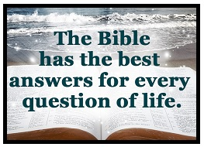

**Lectionary Scripture Readings**

Reading the bible solidifies your faith and builds your doctrine. We become firm in our faith when we know what we actually believe and why we believe it.

**March 5, 2023 - Second Sunday in Lent**

John 3:1-17 - Genesis 12:1-4a - Psalm 121 - Romans 4:1-5, 13-17

Online Lenten devotions: <https://www.luthersem.edu/godpause/lenten-devotional/>



**SAVE THE DATE**

**Our Women’s Fellowship is once again planning a tea party!**

**“TEA BY THE SEA” will be held on Sunday, April 30th.**

**Flyers and tickets will be ready soon.**

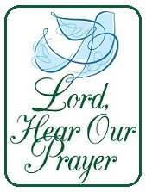

**Joys & Concerns: Keep those prayers going and thank God for His answers! To add a prayer request or share a joy, *please call the church and leave a message. (215) 745-7115*** For many reasons, we pray for others: for comfort, salvation, healing, safety, and so on. Prayer is a way for God to align our hearts with His will. Prayer can be used to pray for someone to come to know God or for their dog to return home.

**Prayer Requests from February 26, 2023**

Cocoa - having trouble with her sight, meeting with doctor today to discuss possible procedure.

Beverly & her daughter (Cocoa's friends) were in a bad car accident - banged up but not seriously injured.

Farol - prayers as she pursues her Bachelor Degree.

Continued prayers for Dot Gallagher

Suzanne Turner's uncle died this week at the age of 101.

Traveling mercies for Paul Wilson.

Phillip appenzeller - prayers for health and healing

Marina - prayers for her family, especially George Peter Kukulay, Aisha Darloma, Cabineh Konnah.

James Browne - starting radiation treatments

Prayers for the Rogers family as they grieve the death of a loved one.

Continued prayers for Dende as she heals from shoulder surgery.

Joy - Pastor Caulker send us his greetings from Sierra Leone

Linda Sutton - prayers for strength and energy

Prayers for Kayla & Christian

Prayers for Lorvens Bernard and the people of Haiti

Martha Korto - is having a cyst removed from her breast on Monday. Prayers for a good outcome.

Philip Appenzeller - prayers for health and healing.

**Continuing Prayers:**

Pastor Randy & Family Sana Aman Eva Baumgartel Suzanne Turner

Zilpha & James Browne Dorothy Buzzard Caroline (Burghaze’s Daughter) Patsy Coyne Rev. Khan Wondor Korto Marva Scott Meyer Bob Patterson Cass Quigley Betty Sauerwald & family Sylvia Spotts

Prayers for the Ukraine and Russia - for world peace.

Prayers for our city and end to violence, prayers for peace and stability in Sierra Leone.



Please pray for the discernment of the cabinet as they select our new Pastor. Please also pray for our congregation that we move forward with joyful anticipation of these new beginnings.



**HEATER FUNDRAISER**

**WE HAVE REACHED OUR GOAL OF $25,000**

*We started this fundraiser in May 2022. We received a grant of $5,000 and a gift from Frankford Memorial UMC in the amount of $5,000. All other contributions made by our congregation and friends of Crescentville UMC totaled $ 15,010.*

***Thank you to all who contributed!!***

***Now we have another goal to reach –*** *our general funds are very low and it soon will be difficult to meet our ongoing expenses including utilities for our Parsonage and Church buildings, as well as salary for our Pastor.* ***PLEASE prayerfully consider raising your weekly monetary offering to help with our expenses.***

***Unsure if you are able to give more? Try taking a step up from your current giving, and if that goes well, take another step – you may find that you can give more that you thought possible.***

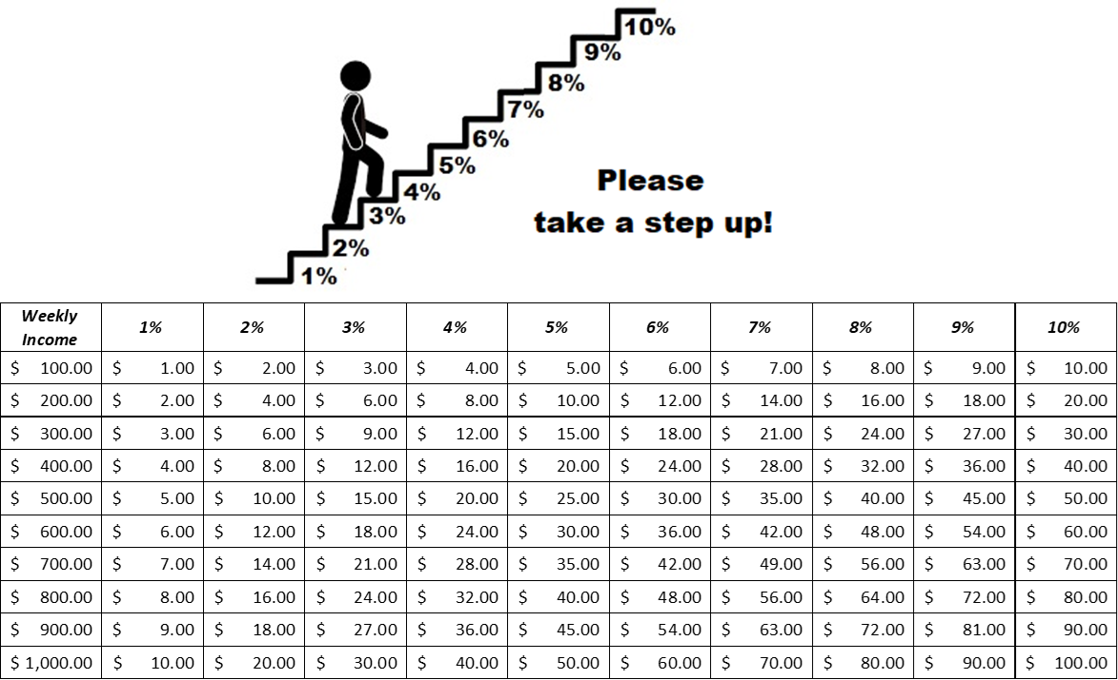

***Luke 6:38 ESV***

***Give, and it will be given to you. Good measure, pressed down, shaken together, running over,***

***will be put into your lap. For with the measure you use it will be measured back to you.”***