May 28, 2023

Crescentville United Methodist Church
A Changing Church for Changing Times
Rev. Randy M. Brubaker, Pastor
412 Sentner Street
Philadelphia, Pennsylvania 19120
215-745-7115
E-Mail: crescentvilleumc@gmail.com
Web Site: https://www.crescentvilleumc.com/
Facebook: https://www.facebook.com/crescentvilleumc
YouTube Channel:
https://www.youtube.com/@crescentvilleunitedmethodi7688

I think it’s safe to say that all of us enjoy receiving gifts. We appreciate the thoughtfulness of those who know us and choose gifts that are fitting to who we are. As today we celebrate God’s gift of the Holy Spirit, given to those who formed the early church, we celebrate a gift that God expects to be utilized “for the good of all.” The Holy Spirit is certainly a gift who helps us throughout our lives, but the Holy Spirit is also Someone who we share with others; to make God known in all the ways we can. Thanks be to God!
- Randy Brubaker
Crescentville & Frankford Memorial United Methodist Churches

Pentecost May 28, 2023

Welcome

Chorus of Welcome “The Family of God”
I’m so glad I’m a part of the family of God—I’ve been washed in the fountain, cleansed by His blood!
Joint heirs with Jesus as we travel this sod; for I’m part of the family, the family of God.

*Call to Worship 1 Corinthians 12

There are different kinds of spiritual gifts, but the same Spirit gives them. There are different ways
of serving, but the same Lord is served. There are different abilities to perform service,
but the same God gives ability to everyone for their particular service. The Spirit’s presence
is shown in some way in each person for the good of all…Christ is like a single body,
which has many parts; it is still one body, even though it is made up of different parts.
In the same way, all of us, whether Jews or Gentiles, whether slaves or free, have been baptized
into the one body by the same Spirit, and we have all been given the one Spirit to drink.

*Opening Hymn “Many Gifts, One Spirit” # 114
God of change and glory, God of time and space, when we fear the future, give to us Your grace.
In the midst of changing ways give us still the grace to praise.

Refrain: Many gifts, one Spirit, one love known in many ways. In our difference is blessing,
from diversity we praise one Giver, one Lord, one Spirit, one Word known in many ways,
hallowing our days. For the Giver, for the gifts, praise, praise, praise!

God of many colors, God of many signs, You have made us different, blessing many kinds.
As the old ways disappear, let Your love cast out our fear. Refrain

Freshness of the morning, newness of each night, You are still creating endless love and light.
This we see, as shadows part, many gifts from one great heart. Refrain

Opening Prayer

O God, in the burning fire of Your love You were pleased to send the Holy Spirit
on Your disciples: Empower us to be grounded in unity, that, evermore living in You,
we may be found both steadfast in faith and active in Your work;
Through Jesus Christ our Lord. Amen.

Children’s Message

Joys & Concerns………………….……..Gathered Prayer…………………………The Lord’s Prayer

Our Father, who art in heaven, hallowed be Thy name; Thy kingdom come, Thy will be done,
on earth as it is in heaven. Give us this day our daily bread; and forgive us our trespasses and debts as we forgive our debtors and those who trespass against us. And lead us not into temptation,
but deliver us from evil. For Thine is the kingdom, and the power, and the glory, forever. Amen.

Gifts and Offerings

Offertory “Holy Spirit”
Doxology “Praise God, From Whom All Blessings Flow” # 94

Praise God, from whom all blessings flow;
praise God, all creatures here below: Alleluia! Alleluia!
Praise God, the source of all our gifts! Praise Jesus Christ, whose power uplifts!
Praise the Spirit, Holy Spirit! Alleluia! Alleluia! Alleluia!

The Offertory Prayer
*Hymn “O Church of God, United” [VS. 1-3] # 547

O church of God, united to serve one common Lord, proclaim to all one message,
with hearts in glad accord. Christ ever goes before us; we follow day by day
with strong and eager footsteps along the upward way.

From every land and nation the ordered ranks appear; to serve one Valiant Leader
they come from far and near. They chant their one confession, they praise one living Lord,
and place their sure dependence upon His saving word.

Though creeds and tongues may differ, they speak, O Christ, of Thee; and in Thy loving spirit
we shall one people be. Lord, may our faithful service and singleness of aim
proclaim to all the power of Thy redeeming name.

Scripture Lesson Acts 2:1-21

When Pentecost Day arrived, they were all together in one place. ² Suddenly a sound from heaven
like the howling of a fierce wind filled the entire house where they were sitting.
³ They saw what seemed to be individual flames of fire alighting on each one of them. ⁴ They were all filled
with the Holy Spirit and began to speak in other languages as the Spirit enabled them to speak.
⁵ There were pious Jews from every nation under heaven living in Jerusalem. ⁶ When they heard
this sound, a crowd gathered. They were mystified because everyone heard them speaking
in their native languages. ⁷ They were surprised and amazed, saying, “Look, aren’t all the people
who are speaking Galileans, every one of them? ⁸ How then can each of us hear them speaking
in our native language? ⁹ Parthians, Medes, and Elamites; as well as residents of Mesopotamia,
Judea, and Cappadocia, Pontus and Asia, ¹⁰ Phrygia and Pamphylia, Egypt and the regions of Libya
bordering Cyrene; and visitors from Rome (both Jews and converts to Judaism), ¹¹ Cretans and Arabs—
we hear them declaring the mighty works of God in our own languages!” ¹² They were all surprised
and bewildered. Some asked each other, “What does this mean?” ¹³ Others jeered at them, saying,
“They’re full of new wine!” ¹⁴ Peter stood with the other eleven apostles. He raised his voice and declared,
“Judeans and everyone living in Jerusalem! Know this! Listen carefully to my words! ¹⁵ These people
aren’t drunk, as you suspect; after all, it’s only nine o’clock in the morning!
¹⁶ Rather, this is what was spoken through the prophet Joel: ¹⁷ In the last days, God says,
I will pour out my Spirit on all people. Your sons and daughters will prophesy. Your young
will see visions. Your elders will dream dreams. ¹⁸ Even upon my servants, men and women,
I will pour out my Spirit in those days, and they will prophesy. ¹⁹ I will cause wonders to occur
in the heavens above and signs on the earth below, blood and fire and a cloud of smoke.
²⁰ The sun will be changed into darkness, and the moon will be changed into blood, before the great
and spectacular day of the Lord comes.
²¹ And everyone who calls on the name of the Lord will be saved.

Sermon “…For the Good of ALL”

*Affirmation of Faith The Apostles’ Creed

I believe in God the Father Almighty, maker of heaven and earth;
And in Jesus Christ His only Son our Lord:
who was conceived by the Holy Spirit, born of the Virgin Mary,
suffered under Pontius Pilate, was crucified, dead, and buried;
the third day He rose from the dead; He ascended into heaven,
and sitteth at the right hand of God the Father Almighty;
from thence He shall come to judge the quick and the dead;

I believe in the Holy Spirit, the holy catholic church,
the communion of saints, the forgiveness of sins,
the resurrection of the body, and the life everlasting. Amen.

*Hymn “Filled With the Spirit’s Power” [TUNE: MORECAMBE] # 537

Filled with the Spirit's power, with one accord the infant church confessed its risen Lord.
O Holy Spirit, in the church today no less your power of fellowship display.

Now with the mind of Christ set us on fire, that unity may be our great desire.
Give joy and peace; give faith to hear your call, and readiness in each to work for all.

Widen our love, good Spirit, to embrace in your strong care all those of every race.
Like wind and fire with life among us move, till we are known as Christ's, and Christians prove.

*Benediction
Quiet Meditation, Reflection, and Prayer

*Choral Benediction “O Church of God, United” [VS. 4] # 547

May Thy great prayer be answered that we may all be one, close bound, by love united
in Thee, God's blessed Son: to bring a single witness, to make the pathway bright,
that souls which grope in darkness may find the One True Light.
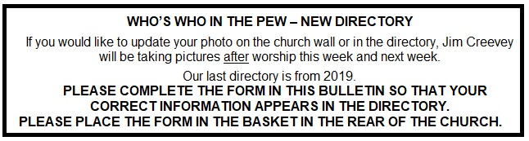

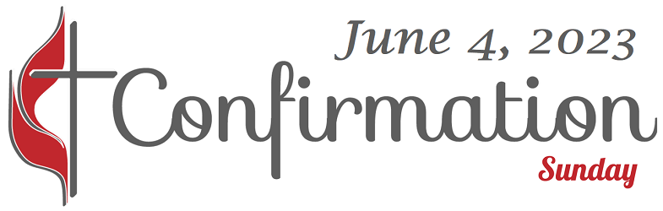 Please make an extra effort to attend this service to support the twelve youth that have finished classes and are ready to confirm their faith. Confirmation marks the first time a baptized Christian publicly "confirms" their intention to live the vows of the baptismal and membership covenant and so becomes a professing member of the local congregation and The United Methodist Church.
AFTER WORSHIP THERE WILL BE A “POTLUCK” LUNCHEON.
PLEASE BRING A DISH OF FODD TO SHARE. BEVERAGES AND DESSERT WILL BE PROVIDED.

Christian Stefanescu Darryl Sutton Jacob Monbo
Joshua Bhatti Kelsey Sutton Marcus Sutton
Mariah Jean Marina Jean Maurice Sutton
Naiima Jabati Naomi Jabati Jahcuerie Sinclair

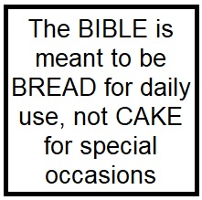
Lectionary Scripture Readings
When we read the bible we learn to live as Jesus modeled while He was on earth. Jesus was interested in and loved people of all kinds while He was on earth. He spent time investing in His disciples, and He spent much time in prayer. He was always about His Father’s business.
June 4, 2023 - Trinity Sunday
Matthew 28:16-20 - Genesis 1:1-2:4a - Psalm 8 - 2 Corinthians 13:11-13

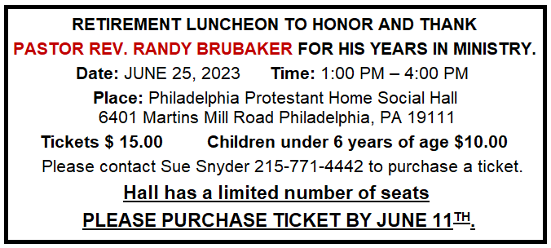Sunday, June 25th – This will be Pastor Randy’s last Sunday as our Pastor. After worship a Retirement Party for Pastor Randy will be held at The Philadelphia Protestant Home. More details to follow later.

Sunday, July 2nd – Pastor Brendan Van Gorder will start his ministry with us.

Sunday July 9th – Friday July 14th - MUSIC & DRAMA CAMP
“The Go Tour” Performances Friday July 14th and Sunday July 16th

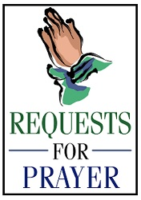Joys & Concerns: Keep those prayers going and thank God for His answers! To add a prayer request or share a joy, please call the church and leave a message. (215) 745-7115. We may not be able to do anything for those we love, but when we pray for them, we join forces with the One who can.

Prayer Requests from May 21, 2023

Traveling mercies for Paul and Allie Wilson
Cocoa - working through PT for left ankle
Prayers for Angel and her family, Angel was committed for Psychiatric care today.
JOY - Farol has been promoted to director at her job.
Bert and Bob Patterson - Bob is on our ongoing prayer list and now his wife Bert is in the hospital.

Pat Raymond & Sue Creevey - as they work through these next weeks. In addition to their ongoing work
Pat has the additional tasks for Frankford Memorial closing, and Sue with additional tasks for
Pastor transition. Prayers for peace through the busyness.

JOY - Marina's daughter Elsie received her Master's Degree
Prayers for the family of Aisha Darloma as they continue to grieve her death.
Traveling mercies for Abdulah
JOY - Ed Paye - grateful for church family, thankful for all things.
Feels that we will go through the Pastor transition well.
Lynn - Prayers for healing for her back.

Continuing Prayers:
Pastor Randy & Family Patsy Coyne Scott Meyer
Sana Aman Rev. Khan Bob Patterson
Eva Baumgartel Martha & Wondor Korto Sylvia Spotts
Zilpha & James Browne Marva Christian Stefanescu
Dorothy Buzzard Kayla Mc Manus Suzzanne Turner
Caroline (Rose Burghaze daughter) Betty Sauerwald & Family
Pastor Brendan Van Gorder
Prayers for the Ukraine and Russia - for world peace.
Prayers for our city and end to violence .
Prayers for peace and stability in Sierra Leone.
Please praise and pray for our youth – they are the future of our Church!

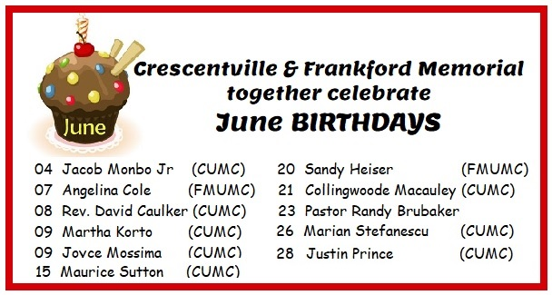

BIRTHDAY RESPONSIVE READING

Celebrants: We thank God for the gift of life.

People: We thank God for you whose birthdays we celebrate this May!

Celebrants: Life is precious.

People: We are grateful for all of you. May God bless you in this time and throughout all your days.

All: We are glad that God has brought us together in this world. We are enriched by those who come into our lives, our families, our church, and our community. May we always be open to seeing God in others. May we always follow God’s leading into the future.

Celebrants: Thanks be To God for the gift of life.

People: Thanks be to God for the gift of life. Amen.

