*“Open my eyes, that I may see glimpses of truth Thou hast for me…” we sometimes sing. But when we sing these words, what do we expect to see? Today, we are reminded of how important it is to have eyes of faith that see what God would have us see. May the words, “Open my eyes” be a prayer, asking God that we would see and know Him in the here and now. – Pastor Randy*

***Crescentville & Frankford Memorial United Methodist Churches***

**All Saints Sunday November 6, 2022**

**Welcome**

Chorus of Welcome *“The Family of God”*

I’m so glad I’m a part of the family of God—I’ve been washed in the fountain, cleansed by His blood!

Joint heirs with Jesus as we travel this sod; for I’m part of the family, the family of God.

**Call to Worship** *Psalms 149 & 150*

*Sing a new song to the Lord; sing God’s praises in the company of the saints….*

*The Lord takes pleasure in His people; God honors the humble with victory…*

*Praise the Lord! Praise God in His sanctuary…*

*Let everything that breathes praise the Lord! Praise the Lord!*

***Dedication of the Pascal Candle***

**Opening Hymn and Naming of Our Saints.** *“For All The Saints”*

For all the saints, who from their labors rest; who You by faith before the world confess

your name, O Jesus, be forever blessed: Alleluia, alleluia!

O blest communion, fellowship divine! We feebly struggle, they in glory shine;

yet all are one in within Your great design. Alleluia, Alleluia!

~~~~~

*We celebrate the communion of saints as we remember the dead, both of the Church universal*

*and of our local congregations. We now name the persons in our congregations who have gone*

*to the church triumphant during the past year.*

**Connie Shuster** (FMUMC) January 11, 2022

**Andrew Potts** (FMUMC) January 30, 2022

**Fred** **Frank** (CUMC) February 22, 2022

**Mary Hom** (FMUMC) August 15, 2022

**Marlin Newcomer** (FMUMC) September 25, 2022

**Rose** **Burghaze** (CUMC) September 26, 2022

**Linda Boettcher** (CUMC) October 8, 2022

*May the souls of all the faithful departed, through the mercy of God, rest in peace.*

~~~~~

*“For All The Saints”*

The golden evening brightens in the west: Soon to the Lord your faithful comes their rest,

sweet is the calm of paradise so blessed. Alleluia, alleluia!

From earth’s wide bounds, from oceans farthest coast, through gates of pearl streams

in the countless host, singing to Father, Son, and Holy Ghost: Alleluia, Alleluia!

**Opening Prayer**

**Almighty God, we thank you for those who have gone on before us, pioneers in faith**

**and ministry, thought, word and deed. We thank you for their example of living a Christ-like life.**

**Help us to remember when we are running the race of life, that all these people stand by us,**

**cheering us on, praying for us, and loving us. Also, Lord in your compassion, comfort those**

**who are grieving the loss of their saint(s). We pray through Jesus Christ our Lord,**

**who with You and the Holy Spirit, lives and reigns, one God for ever and ever. Amen.**

**Children’s Message**

**Joys & Concerns………………….………………………………………………………*Gathered Prayer***

Gifts and Offerings

Offertory *“When The Saints Go Marching In”*

The Doxology *“Praise God, From Whom All Blessings Flow” # 95*

Praise God, from whom all blessings flow; praise Him, all creatures here below;  
praise Him above, ye heavenly host; praise Father, Son, and Holy Ghost. Amen.

**The Offertory Prayer**

**Hymn** *“O God, Our Help in Ages Past”* [VS. 1-3, 6]# 117

O God, our help in ages past, our hope for years to come,  
our shelter from the stormy blast, and our eternal home!

Under the shadow of Thy throne, Thy saints have dwelt secure;  
sufficient is Thine arm alone, and our defense is sure.

Before the hills in order stood, or earth received her frame,  
from everlasting, Thou art God, to endless years the same.

O God, our help in ages past, our hope for years to come;  
be Thou our guide while life shall last, and our eternal home.

**Scripture Lesson** *Ephesians 1:11-23*

We have also received an inheritance in Christ. We were destined by the plan of God,

who accomplishes everything according to his design. **12**We are called to be an honor to God’s glory

because we were the first to hope in Christ. **13**You too heard the word of truth in Christ,

which is the good news of your salvation. You were sealed with the promised Holy Spirit

because you believed in Christ. **14**The Holy Spirit is the down payment on our inheritance,

which is applied toward our redemption as God’s own people, resulting in the honor of God’s glory.

**15**Since I heard about your faith in the Lord Jesus and your love for all God’s people,

this is the reason that **16**I don’t stop giving thanks to God for you when I remember you in my prayers.

**17**I pray that the God of our Lord Jesus Christ, the Father of glory, will give you a spirit of wisdom

and revelation that makes God known to you. **18**I pray that the ***eyes of your heart*** will have enough light

to see what is the hope of God’s call, what is the richness of God’s glorious inheritance

among believers, **19**and what is the overwhelming greatness of God’s power that is working

among us believers. This power is conferred by the energy of God’s powerful strength.

**20**God’s power was at work in Christ when God raised him from the dead and sat him at God’s right side

in the heavens, **21**far above every ruler and authority and power and angelic power,

any power that might be named not only now but in the future. **22**God put everything under Christ’s feet

and made him head of everything in the church, **23**which is his body. ***His body, the church,***

***is the fullness of Christ,*** who fills everything in every way.

**Sermon** *“Open My Eyes…”*

**Affirmation of Faith** *The Apostles’ Creed*

I believe in God the Father Almighty, maker of heaven and earth;

And in Jesus Christ His only Son our Lord: who was conceived

by the Holy Spirit, born of the Virgin Mary,

suffered under Pontius Pilate, was crucified, dead, and buried;

the third day He rose from the dead; He ascended into heaven,

and sitteth at the right hand of God the Father Almighty;

from thence He shall come to judge the quick and the dead;

I believe in the Holy Spirit, the holy catholic church,

the communion of saints, the forgiveness of sins,

the resurrection of the body, and the life everlasting. Amen.

**Service of Holy Communion**

The Lord be with you…………………...….**And also with you.**

Lift up your hearts……………………...…..**We lift them up to the Lord.**

Let us give thanks to the Lord our God…....**It is right to give God thanks and praise.**

...And so, with your people on earth and all the company of heaven

we praise your name and join their unending hymn:

**HOLY, HOLY, HOLY LORD, GOD OF POWER AND MIGHT, HEAVEN**

**AND EARTH ARE FULL OF YOUR GLORY, HOSANNA IN THE**

**HIGHEST. BLESSED IS HE WHO COMES IN THE NAME OF THE**

**LORD. HOSANNA IN THE HIGHEST.**

.

...And so, in remembrance of these your mighty acts in Jesus Christ,

we offer ourselves in praise and thanksgiving as a holy and living sacrifice,

in union with Christ’s offering for us, as we proclaim the mystery of faith.

**CHRIST HAS DIED; CHRIST IS RISEN, CHRIST WILL COME AGAIN.**

...Through your Son Jesus Christ, with the Holy Spirit in your holy Church,

all glory and honor is yours, almighty God, now and for ever. **AMEN.**

*THE LORD'S PRAYER****--****Our Father, who art in heaven,**hallowed be Thy name;**Thy kingdom come,*

*Thy will be done,**on earth as it is in heaven.**Give us this day our daily bread;*

*and forgive us our trespasses and debts as we forgive our debtors and those who*

*trespass**against us. And lead us not into temptation,**but deliver us from evil.*

*For Thine is the kingdom, and the power, and the glory, forever. Amen.*

*BREAKING THE BREAD………………………………….GIVING THE BREAD AND CUP*

*Communion Hymn “In Bread We Bring You Lord”*

**PRAYER AFTER COMMUNION**

**Holy God, the Source of all holiness and Giver of all things good: may we who have shared**

**at this table as strangers and pilgrims here on earth be welcomed with all Your saints**

**to the heavenly feast on the day of Your Kingdom; through Jesus Christ our Lord. Amen.**

**Hymn**  *“O God, Our Help in Ages Past”* [VS. 1, 4-6]# 117

O God, our help in ages past, our hope for years to come,  
our shelter from the stormy blast, and our eternal home!

A thousand ages, in Thy sight, are like an evening gone;  
short as the watch that ends the night, before the rising sun.

Time, like an ever rolling stream, bears all it’s sons away;  
they fly forgotten, as a dream dies at the opening day.

O God, our help in ages past, our hope for years to come;  
be Thou our guide while life shall last, and our eternal home.

**Benediction**

***Quiet Meditation, Reflection, and Prayer***

**Choral Benediction**   *“Blest Be the Tie That Binds”* [VS. 1]# 557

Blest be the tie that binds our hearts in Christian love;

the fellowship of kindred minds is like to that above.

**Joys & Concerns: Keep those prayers going and thank God for His answers! To add a prayer request or share a joy, *please call the church and leave a message.***



***(215) 745-7115.*** For each person who requests our prayer, God is already at work in their lives. In praying for them, we join God’s team to bring change, healing, reconciliation, renewal and transformation in that person’s life.

**Prayer Requests October 30th**

Joy to have our youth leading us in worship.

Welcome Jim Browne to worship and continued prayers as he goes for treatments

Prayers for the Lee family as they face some difficulties this week

Prayers for Eleanor as she recovers from a stroke (friend 0f Cocoa)

Traveling mercies as Lucy (Marian's cousin) returns to Romania

Prayers for Sue Creevey as she has surgery to relieve De Quervain’s Tendinosis

Prayers for Haiti and for Jean Bernard's family.

Prayers for peace in our city.

Welcome home to Manjoe Korpoi who has been traveling in Africa

Joy - Diana & John Wilson continue to celebrate their 60th wedding anniversary

Linda Sutton asked for prayers for peace on her block and the neighborhood.

Joy - Sonja is thankful for good test results

Ed Ingle is in the hospital with sepsis - prayers for good recovery

**Continuing Prayers:**

Pastor Randy & Family Sana Aman Zilpha Browne Dorothy Buzzard

Caroline (Burghaze’s Daughter) Rev. Khan Scott Meyer Ed Ingle Marva Cass Quigley Betty Sauerwald & family Wondor Korto

Sylvia Spotts Suzanne Turner Hank & Eva Baumgartel

Prayers for the Ukraine and Russia - for world peace

Prayers for our city and end to violence

Prayers for peace and stability in Sierra Leone.

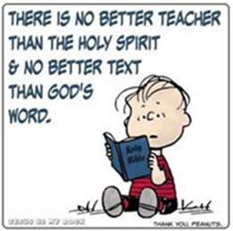

**Lectionary Scripture Readings**

When you understand 000the eternal life God has promised to you, it can help to alleviate a lot of the anxiety you might have in life. Read more here to get more inspiration from the Lord.

**November 13, 2022 – 23rd Sunday after Pentecost**

Luke 21:5-19 - Isaiah 65:17-25 - Isaiah 12 or Psalm 118 - 2 Thessalonians 3:6-13

**NEXT SUNDAY !!**



We will celebrate our 102 years in ministry

on November 13, 2022

with a covered dish luncheon after worship.

Please bring a dish of food to share.

Beverages and desserts will be provided.

If you have missed seeing someone in church, give them a call and invite them to join us on this special day.

Please note the covered dish guidelines in this bulletin.

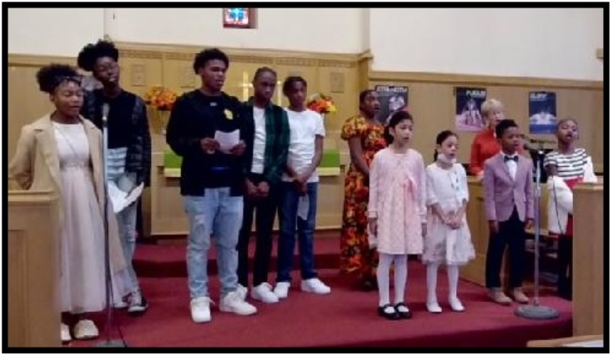

**Our heater replacement fundraiser will be ongoing until the goal is reached!**

**Please continue to prayerfully consider giving a donation towards these costs.**

**You can make as many tributes as you would like,**

**contributing what you can as you can.**

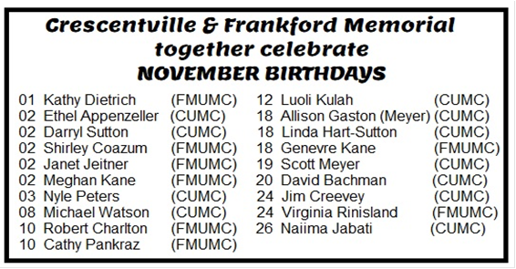

**Guidelines for Potluck/Covered Dish Events**

**A potluck/covered dish is a gathering where each guest contributes a dish of food that is to be shared. To help make our potluck/covered dish luncheons a pleasure for everyone, please help by following these suggested guidelines:**

If you can, please bring a dish of food that will serve 6 or more people. *Please do not bring dessert as desserts and beverages will be provided. Please have your dish prepared when you bring it to church.*

There will be room in the refrigerator for cold items.

We only have one small microwave, so please do not plan to cook your meal in the church kitchen microwave.

There are two kitchen ovens. One will be set at 140 degrees and the other for 200 degrees to keep your meal warm during worship. Your dish would be in the oven for 60-90 minutes at this low temperature.

The ovens will be used for keeping foods warm, so please do not plan to have your meal cooked in the oven during worship, unless it will cook at the low temperatures mentioned.

When you arrive at church, the basement doors will be open. Please take your dish to the kitchen and put it in the oven, refrigerator, or counter, depending on the temperature you want to serve it at.

To avoid congestion in the kitchen after worship, please have your dish ready to serve when you drop it off in the kitchen. After worship, your prepared dish will be set out for our feast.

Please have your name on any dishes or containers that you want to have returned to you. (Using an address label works well for this.) Lids get separated from dishes and containers, so please label both the dish/container and the lid. When you leave, please take your dishes and any of your leftovers with you. Thank you for your help!