October 18, 2026
21ST Sunday After Pentecost
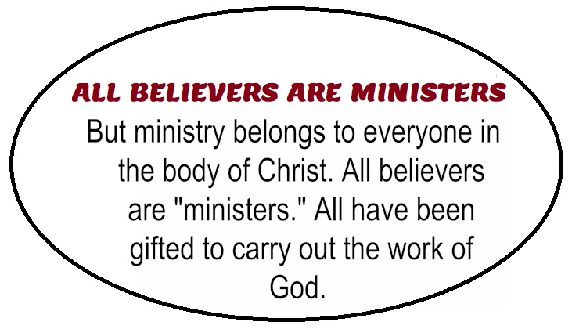

Crescentville United Methodist Church
A Changing Church for Changing Times
Pastor Rev. Lori Reyes
400 Sentner Street
Philadelphia, Pennsylvania 19120
215-745-7115
E-Mail: crescentvilleumc@gmail.com
Web Site: https://www.crescentvilleumc.com/
Facebook: https://www.facebook.com/crescentvilleumc
YouTube Channel:
https://www.youtube.com/@crescentvilleunitedmethodi7688

Crescentville United Methodist Church

21ST Sunday after Pentecost October 18, 2026
Laity Leadership Recognition Sunday

With Grateful Hearts: Today we give thanks for our
church leaders whose faithfulness, dedication, and hard work
help keep the ministry of Crescentville moving forward.
Much of what you do happens quietly behind
the scenes, but it does not go unnoticed.
We see you, we appreciate you, and we thank God for you!

Prelude
PLEASE STAND AS WE BEGIN OUR TIME OF WORSHIP – “Sweet, Sweet Spirit”

Please be seated
Welcome & Announcements

Please stand

Chorus of Welcome Family of God” - Women’s Fellowship October 18, 2022
I’m so glad I’m a part of the family of God—I’ve been washed in the fountain, cleansed by His blood! Joint heirs with Jesus as we travel this sod; for I’m part of the family, the family of God.

Call to Worship
Leader: We are many people, but one body in Christ.
People: Each of us has a place, and each of us belongs.
Leader: Together we worship, together we care, and together we share in ministry.
People: We are the body of Christ.
All: Come, let us worship God together!

Opening Praise Song “The Body Song” by Kids Health Creative

We’re hands to serve and feet to go eyes to see and love to show
each little part has work to do Together we shine as a body so true! (work)

We are the body working as one, from head to toe we get things done!
Each little part has a role to play together we shine in a big big way!

(Where) I am the hands I help and care, I reach to others everywhere
I lift I carry I give and pray helping the world in Jesus way! (Where)

We are the body working as one from head to toe we get things done
each little part has a roll to play together we shine in a big big way

(Where) I Am the feet I walk I run bringing good news to everyone!
step by step I follow His call carrying his message to all (where)

We are the body working as one from head to toe we get things done
each little part has a role to play (to play) together we shine in a big big way!

(Where) I am the heart I love and beat spreading joy to all I meet
compassion flows from deep inside with Jesus love as my guide (hey)

We are the body working as one (working as one)
from head to toe we get things done
Each little part has a role to play together we shine in a big big way!

(Where) We are the body of Christ it's true together bringing His love to you
each one of us has a part to play sharing his love every single day (yeah)

We are the body of Christ it's true together bringing His love to you
each one of us has a part to play sharing his love every single day

Opening Prayer (in unison)

Gracious God,
Thank you for bringing us together as one body in Christ. Remind us that each person matters and each person belongs. As we worship today, strengthen our love for one another and help us remember that ministry belongs to all of us….In Jesus’ name we pray. Amen.

Please be seated
Youth Message

Joys/Concerns – Gathered Prayer

Singing of the Lord’s Prayer - Our Father, which art in heaven, hallowed be Thy name; Thy kingdom come, Thy will be done, on earth as it is in heaven. Give us this day our daily bread; and forgive us our debts as we forgive our debtors. And lead us not into temptation but deliver us from evil. For Thine is the kingdom, and the power, and the glory, forever. Amen

Please be seated
Gifts and offerings
Offertory “Lets Sing Unto The Lord - Verses 1,2” “Please join in singing!
Please stand
The Doxology “Praise God, From Whom All Blessings Flow” # 94
Praise God, from whom all blessings flow; praise God, all creatures here below: Alleluia! Alleluia!
Praise God, the source of all our gifts! Praise Jesus Christ, whose power uplifts!
Praise the Spirit, Holy Spirit! Alleluia! Alleluia! Alleluia!
Offertory Prayer

The youth are dismissed to their classes
Please Stand
Hymn of Reflection “Lord, You Give the Great Commission” Vs 1,2,3 # 584

Lord, you give the great commission: Heal the sick and preach the word."
Lest the church neglect its mission and the gospel go unheard,
help us witness to your purpose with renewed integrity:
With the Spirit's Gifts empower us for the work of ministry.

Lord, you call us to your service: "In my name baptize and teach."
That the world may trust your promise, life abundant meant for each,
give us all new fervor, draw us closer in community:
With the Spirit's Gifts empower us for the work of ministry.

Lord, you make the common holy: "This my body,this my blood."
Let us all, for earth's true glory, daily lift life heavenward,
asking that the world around us share your children's liberty:
With the Spirit's Gifts empower us for the work of ministry.

Please Be Seated
Gospel Lesson 1 Corinthians 12:4-27 Pew Bible page # 1113
Sermon “Ministry Belongs To Everyone”

Please stand
*Affirmation of Faith The Apostles’ Creed
I believe in God the Father Almighty, maker of heaven and earth;
And in Jesus Christ His only Son our Lord:
who was conceived by the Holy Spirit, born of the Virgin Mary,
suffered under Pontius Pilate, was crucified, dead, and buried;
the third day He rose from the dead; He ascended into heaven,
and sitteth at the right hand of God the Father Almighty;
from thence He shall come to judge the quick and the dead;

I believe in the Holy Spirit, the holy catholic church,
the communion of saints, the forgiveness of sins,
the resurrection of the body, and the life everlasting. Amen.

Closing Hymn “Here I Am, Lord” # 593

I, the Lord of sea and sky, I have heard my people cry.
All who dwell in dark and sin my hand will save.
I who made the stars of night, I will make their darkness bright.
Who will bear my light to them? Whom shall I send?

Refrain: Here I am, Lord. Is it I, Lord? I have heard You calling in the night.
I will go, Lord, if You lead me. I will hold Your people in my heart.

I, the Lord, of snow and rain, I have borne my people’s pain.
I have wept for love of them. They turn away.
I will break their hearts of stone, give them hearts for love alone.
I will speak my word to them. Whom shall I send? (Refrain)

I, the Lord of wind and flame, I will tend the poor and lame,
I will set a feast for them. My hand will save.
Finest bread I will provide till their hearts be satisfied.
I will give my life to them. Whom shall I send? Refrain

Benediction

Choral Benediction “The Spirit Sends Us Forth”

We go to be the hands of Christ, to scatter joy like seed
and all our days, to cherish life, to do the loving deed.

Then let us go to serve in peace.The gospel to proclaim.
God’s Spirit has empowered us; We go in Jesus’ name.

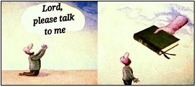
Lectionary Scripture Readings
There are a few really important things in our lives, and our relationship with God is one of them. Reading our Bibles gives us insight into God. We can pray with scripture verses. We can talk to God about things we're reading. We grow in an understanding of God as we read and grasp more of His Word.
October 25, 2026 – 22nd Sunday after Pentecost
Matthew 22:34-36 – Deuteronomy 34:1-12 and Psalm 90:1-6, 13-17 – Acts 10:44-48 –
Leviticus 19:1-2, 15-18 and Psalm 1 – 1 Thessalonians 2:1-8

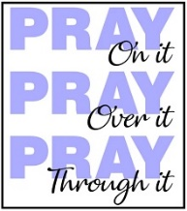
Joys & Concerns: Keep those prayers going and thank God for His answers! To add a prayer request or share a joy, please call or text Sue Creevey 267-847-6029
Praying for one another removes our isolation. We all have struggles that cause us to feel isolated. When we share our pain it invites someone else into the sacred space of our heart. When we hear the emotions of the heart of someone we love, the reflex should be to take those concerns to God in prayer.

Prayer Requests from October 11th
Kass Greenlaw is leaving rehab and will be living for now with her son. She is doing well, even able to care for personal needs. Continued prayers for healing.
This past week Ruth Dillion asked for prayers for her cousin Cindy Berkelback who had spinal/brain surgery. Our prayer group prayed for her this week. Cindy is now in rehab and asking for prayers for recovery and healing.
Prayers for family & friends of Bill Lewis. He has been on our continuous prayer list, and has now gone home to Jesus.
Sue Creevey's brother, Robert Smith is in the hospital being treated for a UTI and also receiving wound care. Prayers for healing.
JOY - Jim & Sue Creevey are celebrating their 51st wedding anniversary today.
Birthday blessing for Majenna Jean. Prayers for the family & friends of Joseph Lemon who died. Traveling mercies for Marina Macauley on her return from Maryland in midweek.
Prayers for the Claudia Johnson family as there has been premature deaths. Prayers for good health, peace and happiness. Pray for all strength during all difficult times.
Carol Evans is having procedures done this week, prayers for good results.
Prayers for Youry Joseph to feel better.
Healing prayers for Keri & John Sanders, Lee & John Waldner
God's blessing on Kristin & Greg, Sean Brett, and Ryan Bresnan.
Continuing Prayers for:
Martha & Wondor Korto Sheryl Duke David & Esther Clinton Amber Sarkar Pastor Lori Lori Rovevelli Robert Smith Walter Rininsland (Joan Pott's Dad) Crescentville UMC Kass Greenlaw Michael Groves
Prayers for those living with constant pain and other ailments.
For those who are sick, and those that grieve. For those who live in war zones and poverty.
For families, especially:
Zilpha and James Browne, The Stefanescu, Mc Manus, Salvadore, and Didirea Families, Jean Bernard and family, The Spotts Family, Bresnan Family
For an end to violence, for peace and stability
Philadelphia, especially our community - Sierra Leone, Africa
Haiti - Israel and Hamas - Ukraine and Russia
Please praise and pray for our youth – they are the future of our church!

UPCOMING EVENTS

Wednesday, Oct 21st Women’s Fellowship Meeting to make soup!

November 01, 2026 – Ad Council Meeting after worship.

